CLUSTER ANALYSIS OF OBJECTIVELY MEASURED PHYSICAL ACTIVITY IN CHRONIC OBSTRUCTIVE PULMONARY DISEASE: A MULTICENTRIC CROSS-SECTIONAL STUDY

Rafael Mesquita^{1,2,}*, Gabriele Spina^{3,}*, Fabio Pitta⁴, David Donaire-Gonzalez⁵, Brenda M. Deering⁶, Mehul S. Patel⁷, Katy E. Mitchell⁸, Jennifer Alison⁹, Arnoldus J. R. van Gestel¹⁰, Stefanie Zogg¹¹, Judith Garcia-Aymerich⁵, Kylie Hill^{12,13}, Elisabeth A. P. M. Romme¹⁴, Samantha S.C. Kon⁷, Paul S. Albert¹⁵, Benjamin Waschki¹⁶, Dinesh Shrikrishna⁷, Sally J. Singh⁸, Nicholas S Hopkinson⁷, David Miedinger¹¹, Christine Jenkins¹⁷, Michael I. Polkey⁷, Sue C. Jenkins¹³, William D-C. Man⁷, Christian F. Clarenbach¹⁰, Nidia A. Hernandes⁴, Daniela Savi¹⁵, David R. Hillman¹⁸, Karina C. Furlanetto⁴, Zoe J. McKeough¹⁹, Sally Watts¹⁹, Li W. Cindy Ng¹³, Dina Brooks¹², Peter R. Eastwood¹⁸, Thaís Sant'Anna⁴, Kenneth Meijer²⁰, Selina Dürr¹¹, Malcolm Kohler¹⁰, Vanessa S. Probst^{4,21}, Ruth Tal-Singer²², Jörg Leuppi¹¹, Peter M.A. Calverley¹⁵, Frank W. J. M. Smeenk¹⁴, Julie Yates²², Richard W. Costello⁶, Roger Goldstein¹², Helgo Magnussen¹⁶, Emiel F.M. Wouters^{1,2}, Richard L. ZuWallack²³, Oliver Amft^{3,†}, Henrik Watz^{16,†}, and Martijn A. Spruit^{1,†}.
Still to include here: Abascal-Bolado B.1,2 Benzo RP.2
1 Division of Pulmonary. Hospital U. Marqués de Valdecilla. IFIMAV (Spain).
2 Division of Pulmonary and Critical Care. Breathing and Behavior Laboratory. Mayo Clinic. Rochester, MN (USA).
Diana Jarreta*
*R&D Centre, Almirall, Barcelona, Spain.
Philippe Gagnon*, François Maltais*.
Affiliation: *Centre de recherche, Institut Universitaire de cardiologie et de pneumologie de Québec, 2725 Chemin Ste-Foy Québec, Université Laval, Québec G1V 4G5, Canada.
Barbara Vagaggini, Pierluigi Paggiaro.
Affiliation: Cardio-Thoracic and Vascular Department, University of Pisa, Italy.
Anne Kirsten and Marco Gramm from Grosshansdorf, Germany.
*Joint first authors †Joint senior authors

¹Department of Research & Education, CIRO+, center of expertise for chronic organ failure+, Horn, The Netherlands.
²Department of Respiratory Medicine, Maastricht University Medical Center+ (MUMC+), Maastricht, The Netherlands.
³ACTLab, Signal Processing Systems, TU Eindhoven, Eindhoven, The Netherlands.
⁴Laboratório de Pesquisa em Fisioterapia Pulmonar, Departamento de Fisioterapia, Universidade Estadual de Londrina (UEL), Londrina, Paraná, Brazil.
⁵Centre for Research in Environmental Epidemiology (CREAL), Barcelona, Spain.
⁶Department of Respiratory Medicine, Beaumont Hospital, Dublin, Ireland.
⁷NIHR Respiratory Biomedical Research Unit, Royal Brompton & Harefield NHS Foundation Trust and Imperial College, London, United Kingdom.
⁸NIHR CLAHRC-LNR Pulmonary Rehabilitation Research Group, University Hospitals, Leicester, United Kingdom.
⁹Physiotherapy Department, Royal Prince Alfred Hospital, Sydney, NSW, Australia.
¹⁰Pulmonary Division, University Hospital of Zurich, Zurich, Switzerland.
¹¹Internal Medicine, University Hospital of Basel, Basel, Switzerland.
¹²Respiratory Medicine, West Park Healthcare Centre, Toronto, Canada.
¹³School of Physiotherapy and Curtin Health Innovation Research Institute, Curtin University, Perth, WA, Australia.
¹⁴Department of Respiratory Medicine, Catharina Hospital, Eindhoven, The Netherlands.
¹⁵School of Ageing and Chronic Disease, University Hospital Aintree, Liverpool, United Kingdom.
¹⁶Pulmonary Research Institute at Hospital Grosshansdorf, Member of the German Centre for Lung Research, Grosshansdorf, Germany.
¹⁷Woolcock Institute of Medical Research, The University of Sydney, Camperdown, Australia.
¹⁸Department of Pulmonary Physiology, Sir Charles Gairdner Hospital, Perth, WA, Australia.
¹⁹Clinical and Rehabilitation Sciences, The University of Sydney, Sydney, NSW, Australia.
²⁰Department of Human Movement Science, Faculty of Health, Medicine and Life Sciences, Maastricht University, Maastricht, The Netherlands.
²¹Centro de Pesquisa em Ciências da Saúde, Centro de Ciências Biológicas e da Saúde, Universidade Norte do Paraná (UNOPAR), Londrina, Paraná, Brazil.
²²GlaxoSmithKline, King of Prussia, PA, United States of America.
²³Department of Pulmonary and Critical Care, Saint Francis Hospital and Medical Center, Hartford, CT, United States of America.

Financial support: RM is supported by CNPq, Conselho Nacional de Desenvolvimento Científico e Tecnológico – Brazil (246704/2012-8). Point-One funding from AgentschapNL, Dutch Ministry of Economic affairs, Netherlands. For centres: please add here your own financial support, if there is any.

Correspondence:
Rafael Mesquita, MSc, PT
Department of Research & Education, CIRO+, center of expertise for chronic organ failure+; Hornerheide 1, 6085 NM, Horn, The Netherlands; Telephone number: +31 475 587 645; Email: rafaelmesquita14@ymail.com
ABSTRACT (≤250 words)

Keywords: XXXxx.
INTRODUCTION (suggestion: no more than 1 page and half)

Patients with COPD have lower physical activity levels compared to healthy elderly subjects.¹⁻³ Lower physical activity has been associated with various health outcomes in patients with COPD, including hospitalization and death.^{4,5} Therefore, a greater awareness of the clinical importance of physical inactivity in COPD is needed amongst healthcare professionals and scientists.REF

Different tools have been used to assess physical activity in patients with COPD, including patient-reported outcome questionnaires and activity monitoring.⁶ The use of activity monitors has become popular in patients with COPD, as these devices can provide more detailed information of physical activity levels during the day compared to questionnaires.^{7,8}

To date, most COPD studies that used activity monitors have reported only the average daily physical activity level and its standard deviation.⁹⁻¹² Donaire-Gonzalez and colleagues¹³ were the first to perform a more detailed analysis of physical activity in patients with COPD. Indeed, patients with COPD performed bouts of moderate-to-vigorous physical activity, and the frequency of these bouts was inversely associated with the degree of airflow limitation.¹³ Nevertheless, multiple other options are also available, such as temporal patterns of physical activity,¹⁴ and even physical activity cluster analysis.¹⁴⁻¹⁷

A temporal analysis of physical activity patterns can reveal whether specific physical activities are concentrated during certain periods of the day;¹⁴ while cluster analysis is able to identify subgroups of patients with similar physical activity patterns.¹⁸ This detailed information will provide a better insight in physical activity of patients with COPD. This may be also be of clinical importance, as many interventions thus far have failed to promote important increase mean physical activity levels in patients with COPD.^{19,20}

To the best of our knowledge, temporal patterns of physical activity and cluster analysis of physical activity patterns have not been investigated in patients with COPD. Therefore, we aimed: 1) to describe the heterogeneity of physical activity in patients with COPD, after stratifying for known confounders; 2) to compare physical activity patterns between patients with COPD and healthy subjects, matched for age, gender and body mass index; 3) to identify clusters of physical activity in patients with COPD; and 4) to investigate and compare clinical characteristics and temporal patterns of physical activity between physical activity clusters.

METHODS (suggestion: no more than 3 pages and half)

Study design and participants
In this multi-center cross-sectional study, a secondary analysis of objectively assessed physical activity data from 10 different countries was performed. Researchers from the United Kingdom (UK), Ireland, Netherlands, Germany, Switzerland, Italy, Spain, the United States of America (USA), Brazil and Australia on possession of published and/or unpublished physical activity data (with no overlapping analysis) as assessed by the activity monitor SenseWear Armband or SenseWear Mini Armband (both from BodyMedia Inc., Pittsburgh, PA, USA) were invited to share their data for the current analyses. References of previously published data can be found in the online supplement. Subjects were included if they presented: COPD with a post-bronchodilator forced expiratory volume in the first 1 s (FEV₁) / forced vital capacity (FVC) ratio <0.7²¹, stable condition (i.e., no recent exacerbation), and complete data for age, gender, body mass index (BMI) and daily levels of physical activity (see Physical activity assessment section for details).

Demographics, anthropometrics, lung function, and clinical data were collected: age, gender, BMI (weight in kg per squared height in m),²² FEV₁ (% of predicted), FEV₁/FVC ratio, diffusion capacity of the lung for carbon monoxide (D_{LCO}, % of predicted), symptoms of dyspnea by the modified Medical Research Council (mMRC) dyspnea grade,²³ and the use of walking aids (yes/no) and long-term oxygen therapy (yes/no). In addition, subjects were stratified by BMI (underweight (<21 kg∙m⁻²), normal weight (21 to 24.99 kg∙m⁻²), overweight (25 to 29.99 kg∙m⁻²), or obese (≥ 30 kg∙m⁻²)²⁴ and GOLD 1 to 4.²¹

Some centers also had available a sample of healthy subjects with similar characteristics and were invited to also share this sample for the current study. These subjects had to fulfill the same inclusion criteria except those related to the diagnosis of COPD.

Physical activity assessment
The SenseWear Armband and SenseWear Mini Armband activity monitors (both from BodyMedia Inc., Pittsburgh, PA, USA) were used for the assessment of physical activity. These devices combine an accelerometer with different physiological sensors (i.e., a heat flux sensor, a galvanic skin response sensor, a skin temperature sensor, and a near-body ambient temperature sensor). Together with demographic characteristics, such as gender, age, height, and weight, energy expenditure can be estimated using proprietary algorithms developed by the manufacturer. The SenseWear Armband has been shown to be valid in both field^{25,26} and laboratory studies.²⁷⁻²⁹ The following thresholds proposed by the American College of Sports Medicine (ACSM)³⁰ were used to classify the intensity of activities: very light intensity (VLI): <2.0 METs; light intensity (LI): 2.0 to 2.9 METs; and moderate-to-vigorous intensity (MVI): ≥3.0 METs.

A minimum of four days (2 week days + Saturday + Sunday) was considered acceptable,⁹ with the device being used for ≥22 hours.³¹ Data were analyzed using the software SenseWear Professional 6.1; only in a small portion of data (13%) version 7.0 had to be used instead. Regardless the version, the software provides minute-by-minute energy expenditure and METs. These two variables were stratified according to the duration of PA (e.g., bouts of activity), period of PA (i.e., before or after midday), intensity (i.e., VLI, LI and MVI) and , leading to 180(or 182? Ask Gabriele! Ask him also about % tot assessment time, is the total duration of the total daily/averaged duration) variables, which were used for the cluster analysis. These variables can be found in the online supplement. To reduce the variability in the results, only results during week days were used for analysis.

Mention why 2-min bouts.

Statistical Analysis
Continuous variables were expressed as median (interquartile range), as most variables presented non-normal distribution. Categorical variables were expressed as absolute and/or relative frequency. Mann-Whitney U test or Kruskal-Wallis test (followed by Dunn’s test) was used for the comparison of continuous variables, while the chi-square test was used for categorical variables. Spearman coefficient was used to investigate correlations, when appropriate. All statistical analyses were performed using SPSS 17.0 (SPSS, Chicago, Illinois, USA) or GraphPad Prism 5 (GraphPad Software, La Jolla, California, USA).

Description of cluster analysis: Matlab version? (Mathworks Inc., USA),

Cluster analysis: 182 variables generated, values during week days only.
- Categorical data expressed as absolute and/or relative frequency and continuous data expressed as median (interquartile range)
- Mann-Whitney test for comparison between sub-groups
- Kruskal-Wallis test for comparison among sub-groups (Dunn’s post hoc)
- Spearman correlation coefficient
- Principal Component Analysis (PCA) for features’ selection
- kmean for clustering.

To mention in the Methods: by levels of physical activity were considered the variables collected from the SenseWear, while by patterns of physical activity we considered the graphic representation of the median intensity during a day.

RESULTS (suggestion: no more than 3 pages)

General characteristics
In total, 1001 patients with COPD fulfilled the inclusion criteria and were included in the current study. The number of subjects per country of recruitment can be found in the online supplement (Table E1). Table 1 presents the general characteristics of the subjects. Most of them were men, presented moderate-to-severe degree of airflow limitation, and only a small proportion of patients was on long-term oxygen therapy or was user of walking aids.

TABLE 1. GENERAL CHARACTERISTICS OF THE PATIENTS WITH COPD
Characteristic | Value
N | 1001
Age, yrs | 67 (61 – 72)
Male, n / % | 654 / 65
Weight, kg | 74 (62 – 87)
Height, m | 1.70 (1.63 – 1.75)
BMI, kg·m⁻² | 25.8 (22.5 – 29.6)
BMI classification, %  Underweight  Normal weight  Overweight  Obese | 7  37  34  22
mMRC dyspnea grade* | 2 (1 – 3)
Long-term oxygen therapy, n / %† | 67 / 10
Walking aid, n / %‡ | 19 / 3
FEV₁, L | 1.31 (0.91 – 1.79)
FEV₁, % predicted | 49 (34 – 64)
FEV₁/FVC, % | 45 (35 – 56)
DLCO, % predicted§ | 51 (37 – 67)
GOLD grades 1/2/3/4, % | 9 / 40 / 34 / 17
Data expressed as absolute / relative frequency or median (interquartile range). BMI: body mass index; mMRC: modified Medical Research Council; FEV₁: forced expiratory volume in the first second; FVC: forced vital capacity; DLCO: diffusion capacity of the lung for carbon monoxide; GOLD: Global Initiative for Chronic Obstructive Lung Disease. *Data missing for 133 subjects; †Data missing for 294 subjects; ‡Data missing for 296 subjects; §Data missing for 496 subjects.

Daily levels and patterns of physical activity
The median number of valid days was 6 (6 – 6) days, but the sum of all valid days equaled to 6074 days, with 4049 were week days. The physical activity assessments were almost evenly distributed among the four seasons of the year: summer, n=264 (26%); autumn, n=333 (33%); winter, n=229 (23%); and spring, n=175 (18%).

Table 2 presents the daily levels of physical activity during week days (the median number of week days was 4 (4 – 4) days). The smallest amounts of time and EE were spent in MVI. In general, these variables were almost 2 fold higher after midday than before midday, except for the results in MVI. Regarding bouts of physical activity, the subjects spent a median of only 6 (0 – 22) min·day⁻¹ in bouts of at least 10 minutes, suggesting that not all days presented bouts with this duration, as the amount of time spent is smaller than the bouts duration. On the other hand, a median of 38 (17 – 79) min·day⁻¹ was spent in bouts of at least 2 minutes, and these bouts had a median average duration of 4 (3 – 5) min·bout⁻¹ and were more frequent during the day than 10-minute bouts.

TABLE 2. DAILY LEVELS OF PHYSICAL ACTIVITY DURING WEEK DAYS IN PATIENTS WITH COPD
 | General physical activity
Variable | VLI | LI | MVI
Time, min∙day⁻¹  Before midday  After midday  Total | 283 (236 – 347)  514 (449 – 577)  803 (710 – 901) | 49 (31 – 74)  88 (53 – 123)  142 (92 – 194) | 21 (10 – 42)  27 (13 – 59)  52 (26 – 99)
EE, METs-min∙day⁻¹  Before midday  After midday  Total | 364 (274 – 502)  668 (521 – 858)  1032 (822 – 1327) | 154 (95 - 263)  273 (167 – 413)  435 (291 – 655) | 110 (46 – 232)  147 (65 – 310)  267 (132 – 550)
 | Bouts of physical activity
Variable | VLI | LI | MVI
Time, min∙day⁻¹  ≥2-minute  Before midday  After midday  Total  ≥10-minute  Before midday  After midday  Total | 273 (225 – 338)  503 (435 – 569)  781 (683 – 884)  215 (167 – 284)  436 (352 – 526)  657 (539 – 780) | 37 (22 – 59)  67 (37 – 97)  107 (65 – 156)  3 (0 – 8)  4 (0 – 14)  7 (0 – 22) | 15 (6 – 34)  20 (8 – 47)  38 (17 – 79)  2 (0 – 11)  3 (0 – 13)  6 (0 – 22)
Frequency, bouts∙day⁻¹  ≥2-minute  Before midday  After midday  Total  ≥10-minute  Before midday  After midday  Total | 21 (17 – 25)  27 (21 – 34)  48 (39 – 58)  7 (6 – 9)  11 (9 – 13)  18 (16 – 21) | 11 (7 – 16)  19 (11 – 26)  31 (20 – 41)  0 (0 – 1)  0 (0 – 1)  1 (0 – 2) | 4 (2 – 8)  5 (2 – 10)  10 (5 – 17)  0 (0 – 1)  0 (0 – 1)  1 (0 – 2)
Average duration, min∙bout⁻¹  ≥2-minute  Before midday  After midday  Total  ≥10-minute  Before midday  After midday  Total | 13 (10 – 17)  18 (13 – 27)  16 (12 – 21)  29 (24 – 36)  37 (29 – 50)  34 (28 – 43) | 3 (3 – 4)  3 (3 – 4)  3 (3 – 4)  10 (0 – 13)  11 (0 – 13)  12 (0 – 14) | 4 (3 – 5)  4 (3 – 5)  4 (3 – 5)  10 (0 – 15)  11 (0 – 15)  13 (0 – 16)
EE, METs-min∙day⁻¹  ≥2-minute  Before midday  After midday  Total  ≥10-minute  Before midday  After midday  Total | 347 (261 – 490)  648 (501 – 845)  1000 (783 – 1298)  273 (193 – 411)  572 (410 – 783)  847 (626 – 1168) | 118 (67 – 205)  211 (119 – 335)  340 (204 – 523)  6 (0 – 26)  14 (0 – 47)  26 (0 – 77) | 86 (29 – 187)  106 (41 – 255)  205 (86 – 436)  9 (0 – 61)  12 (0 – 69)  36 (0 – 132)
Data expressed as median (interquartile range). VLI: very light intensity; LI: light intensity; MVI: moderate-to-vigorous intensity; EE: energy expenditure; MET: metabolic equivalent of task.

Stratification for possible confounders
Daily levels of physical activity after stratification for general characteristics can be found in the online supplement (Tables E2-E9). Briefly, older subjects, women, subjects on LTOT, subjects making use of walking aids and subjects with a lower DLCO spent less time and EE in MVI than their counterparts, considering both non-bouts and bouts analyses. Obese subjects, subjects with a mMRC grade of 4 and subjects with a GOLD grade of 3 or 4 also presented reduced time and EE in MVI. Figure 1 presents the hourly pattern during week and weekend days after stratification for general characteristics. In general, there is almost no influence of age, gender, use of LTOT, and DLCO on the hourly patterns. On the other hand, there is an obvious influence of BMI, mMRC grades, and use of walking aids. The influence of GOLD grades on the hourly patterns is little. It was also observed a weak correlation between the degree of airflow limitation and the time in MVI (r_{s}=0.20, P<0.0001; Figure 2).
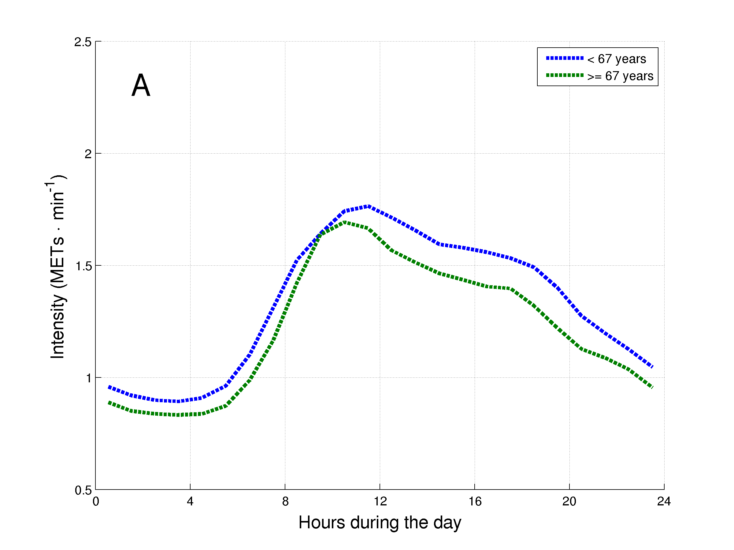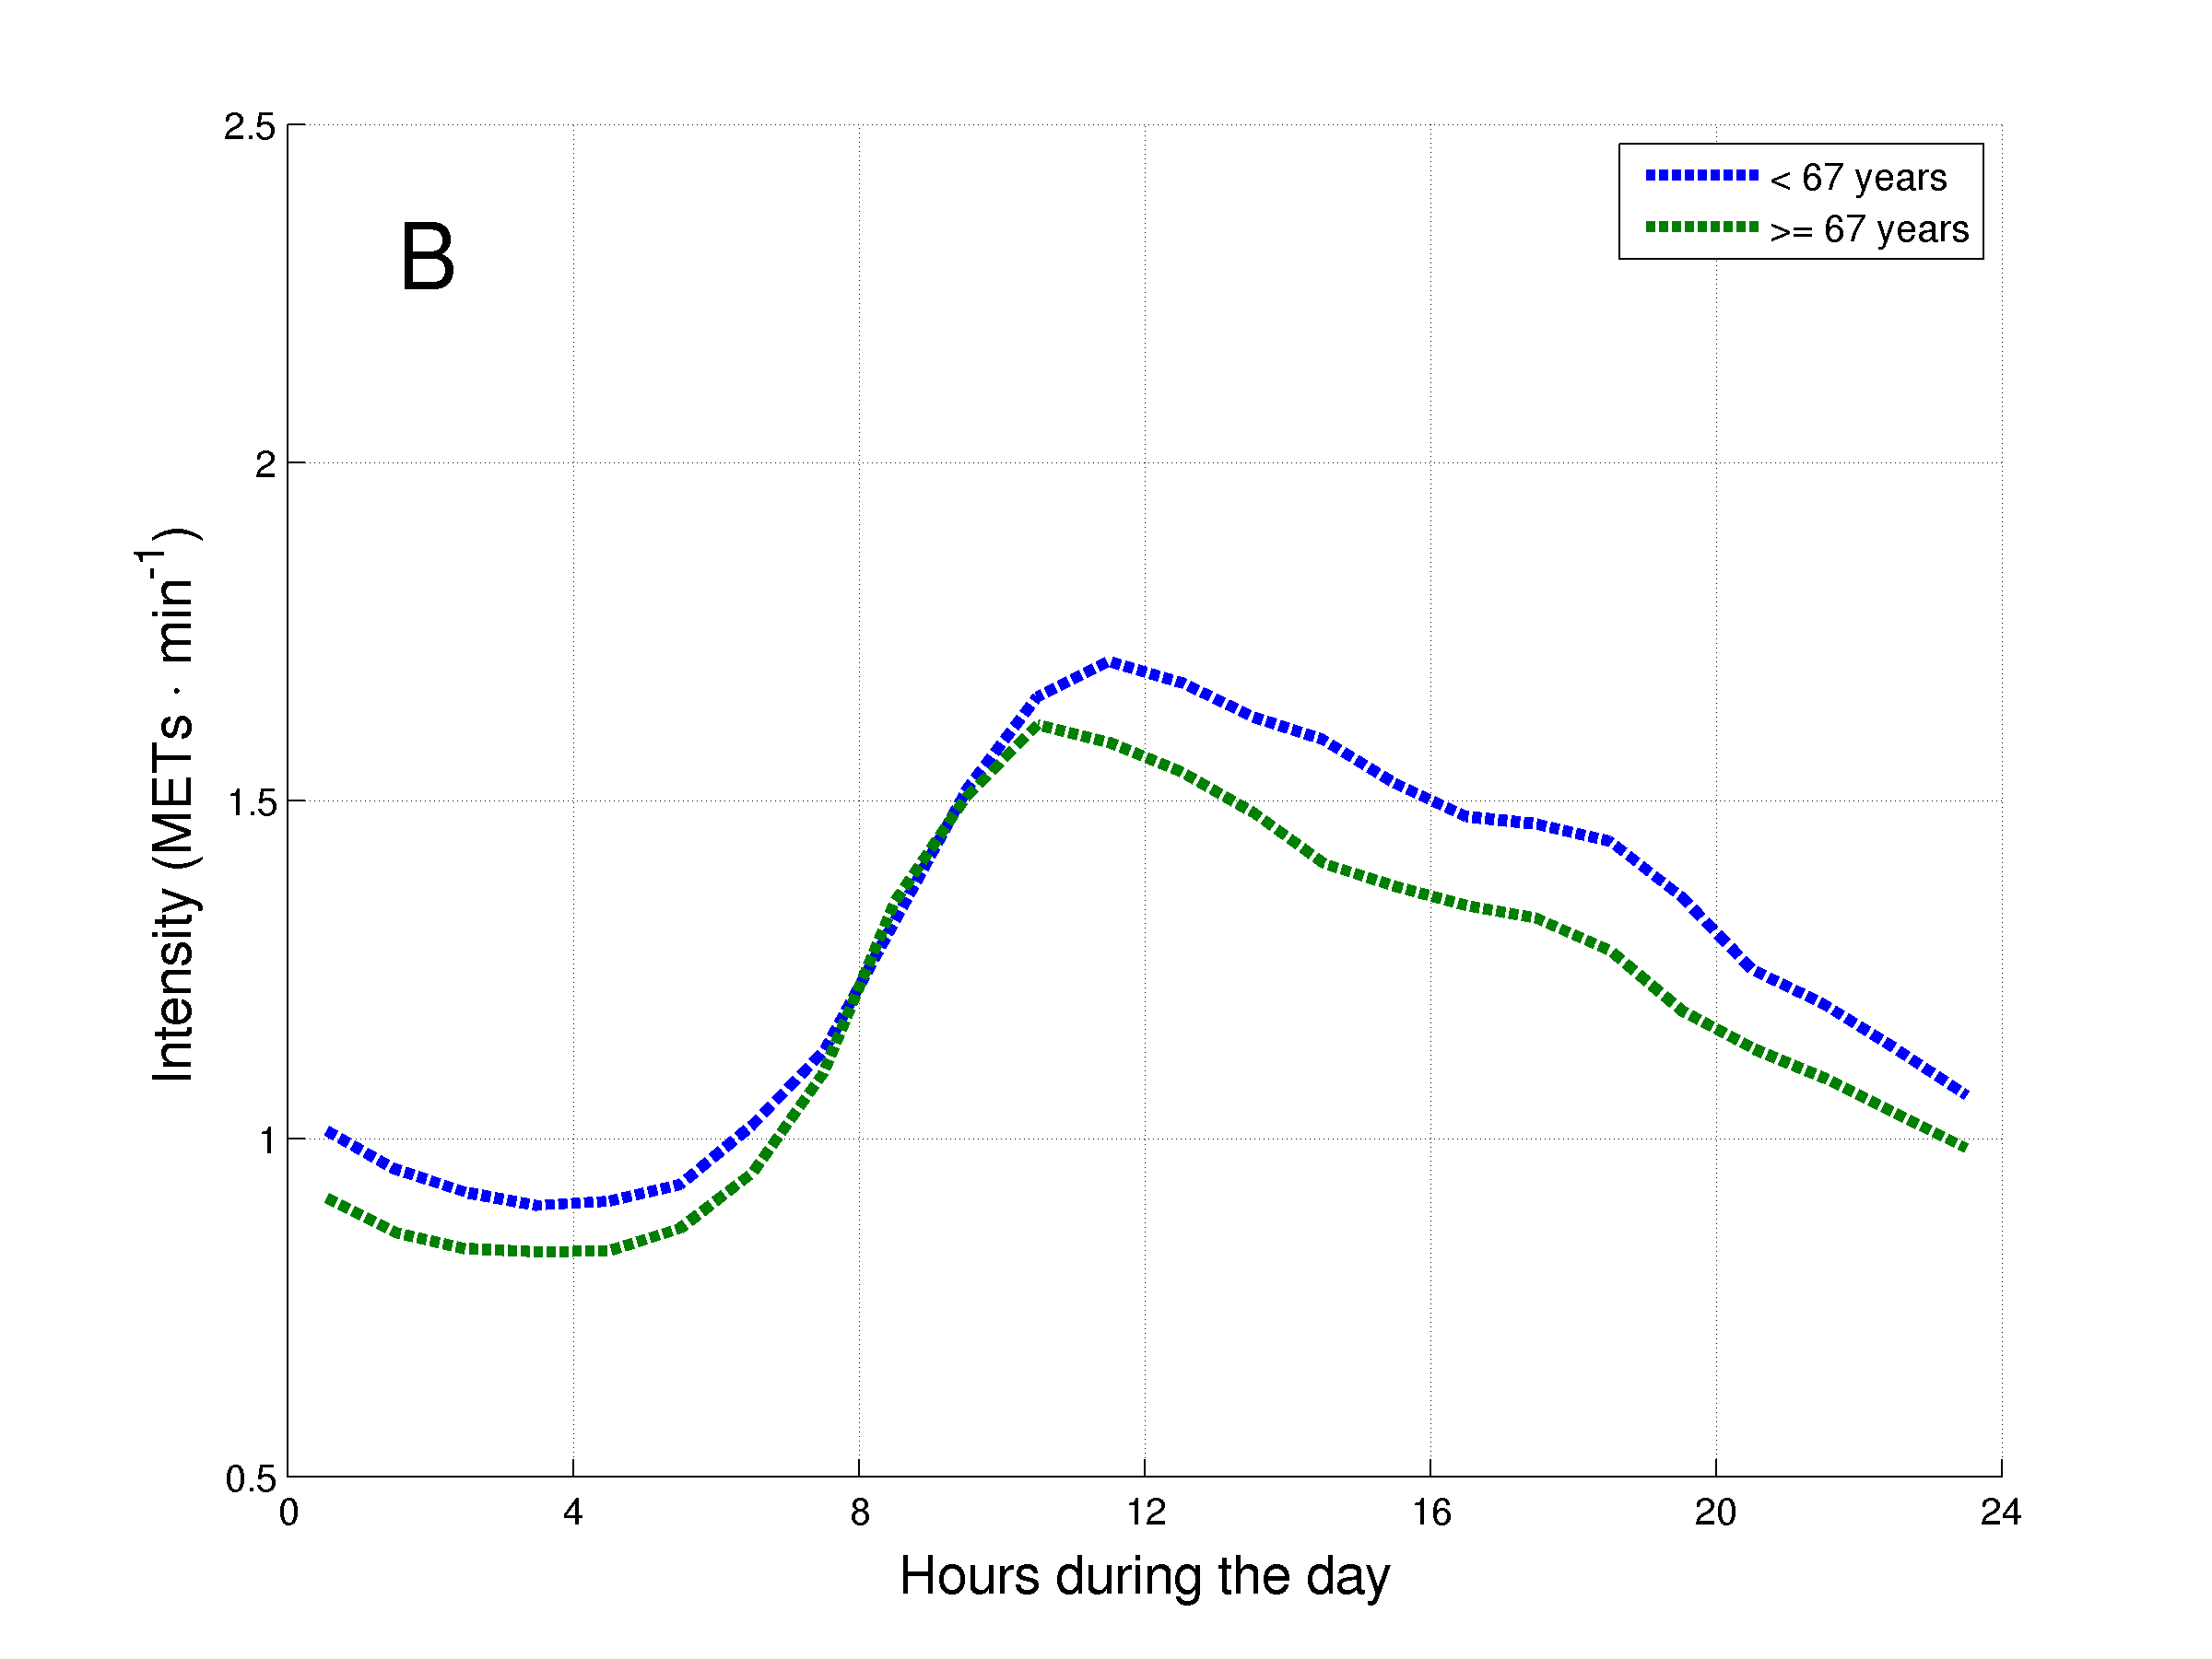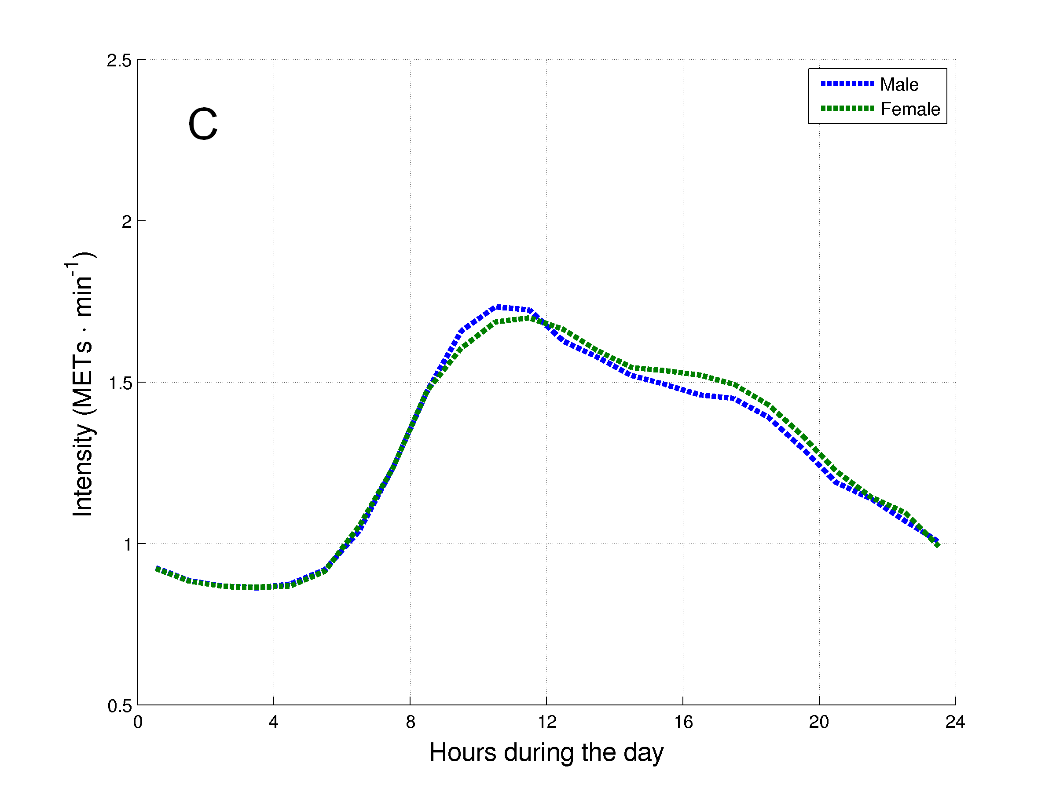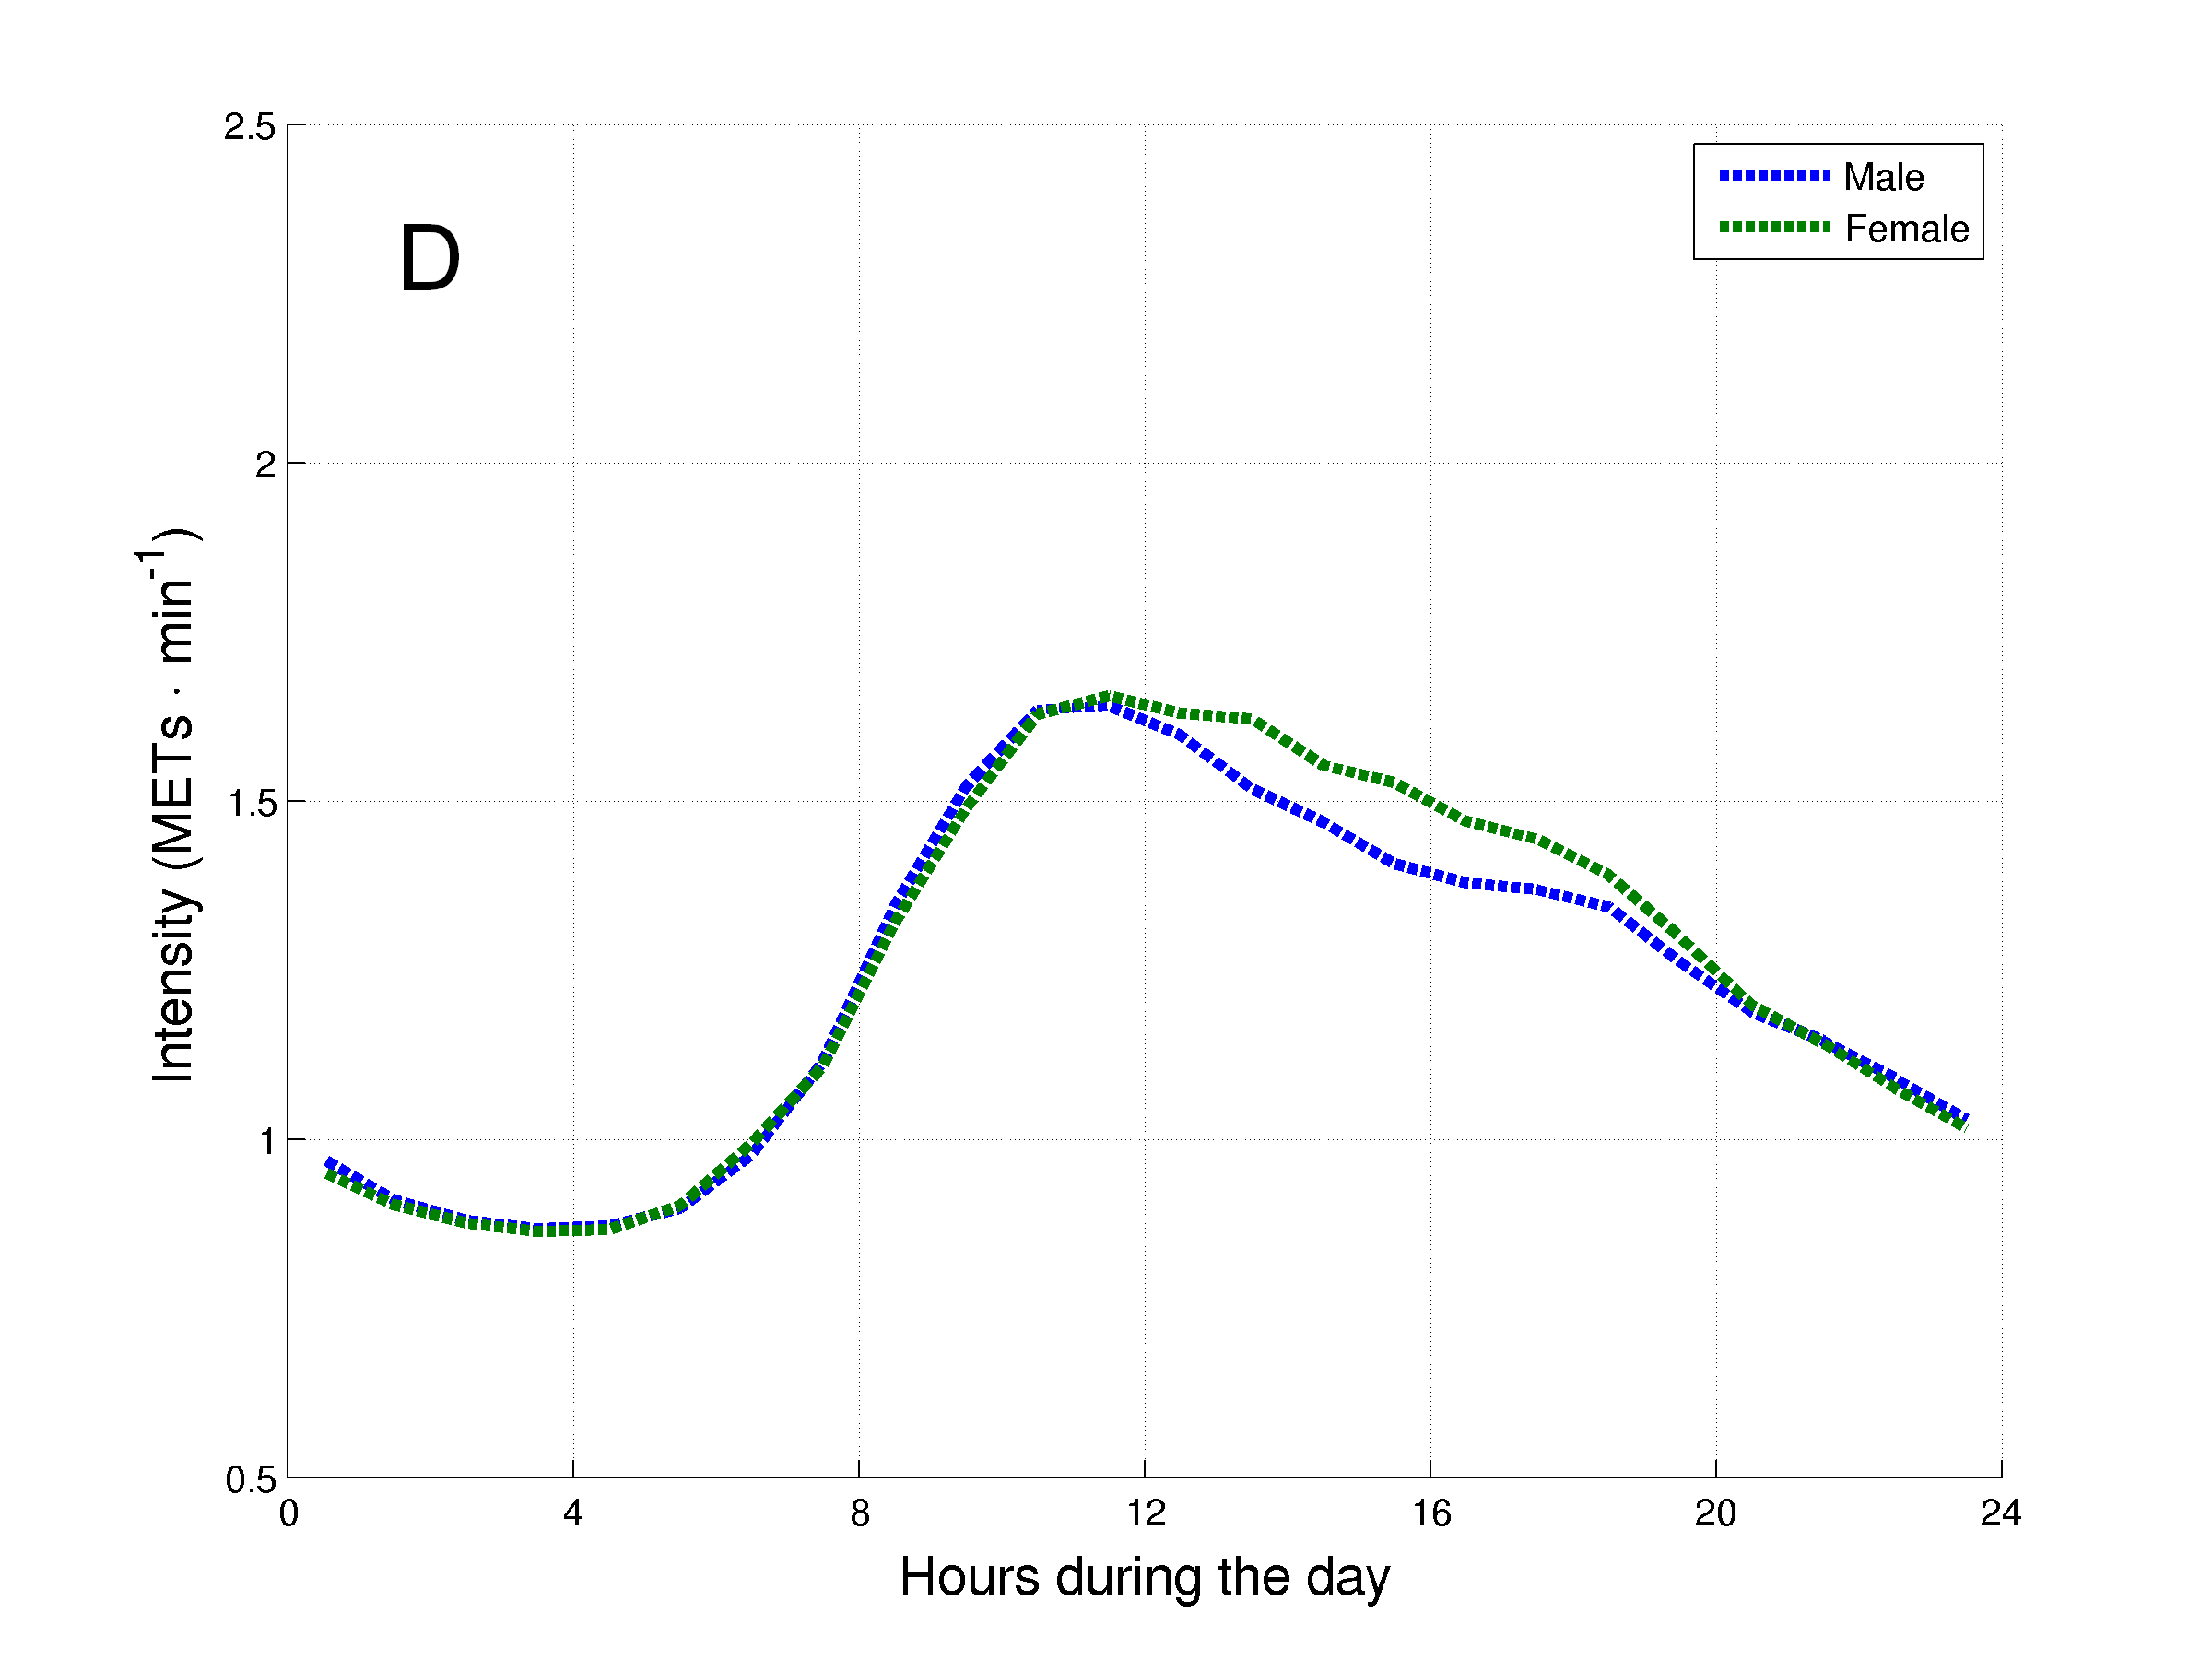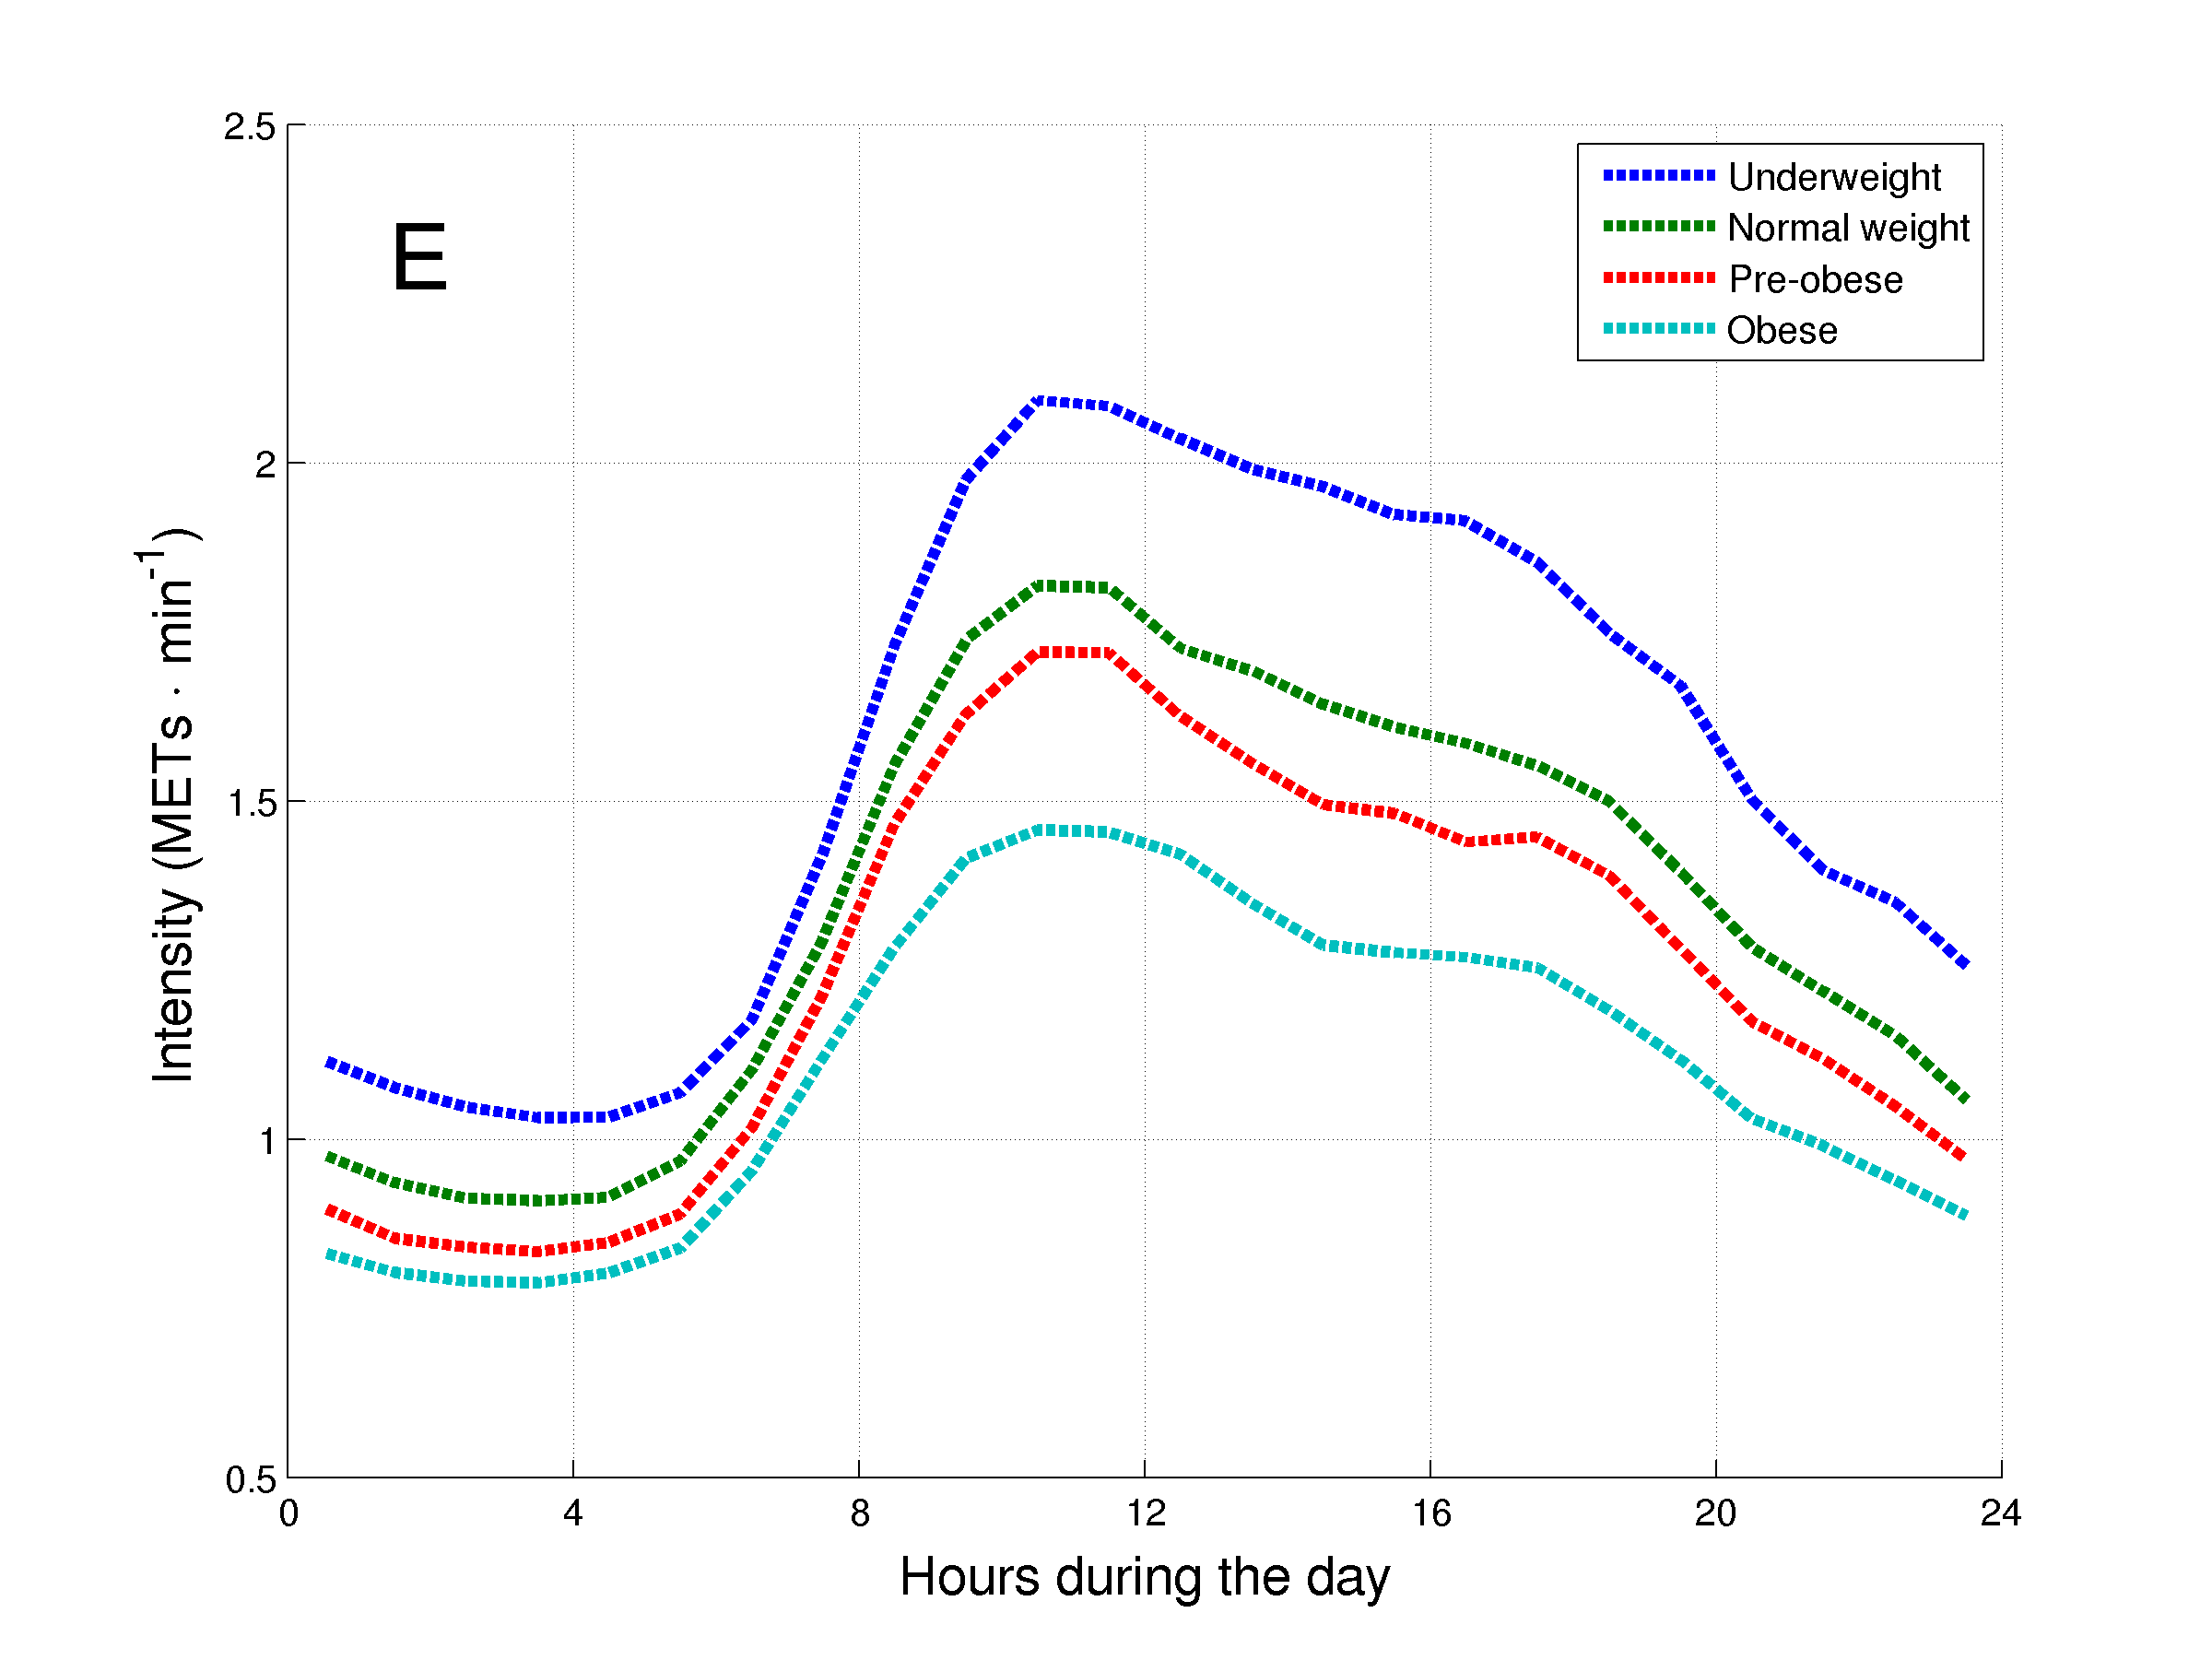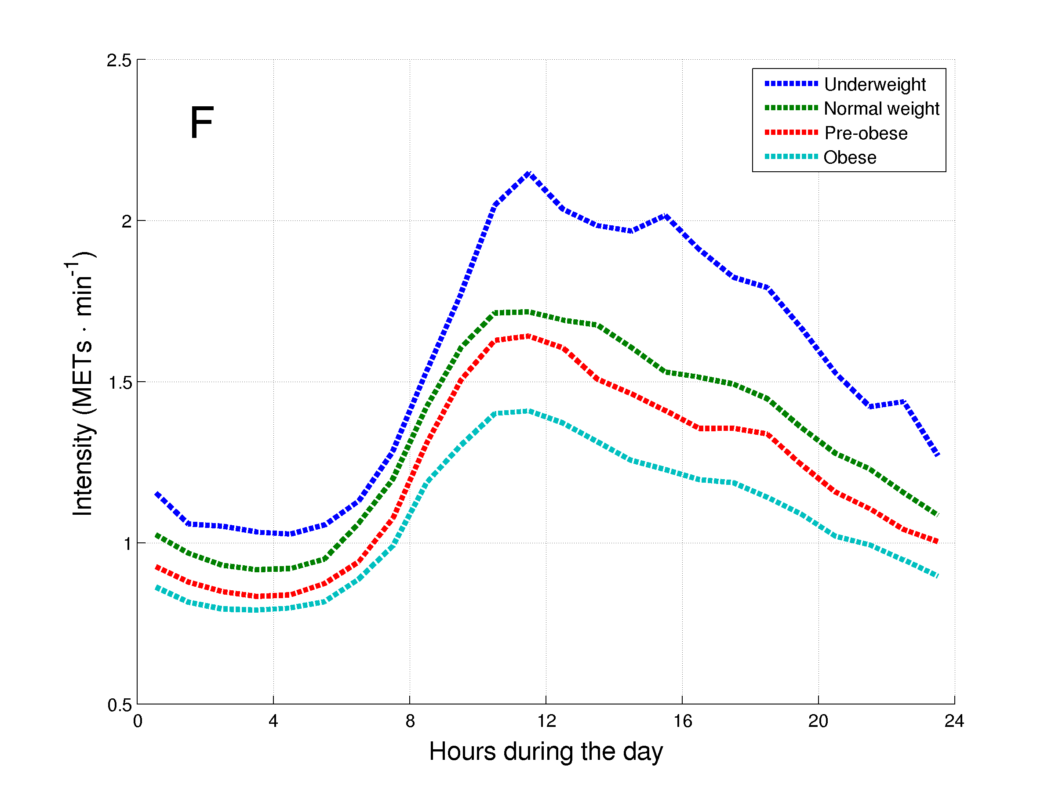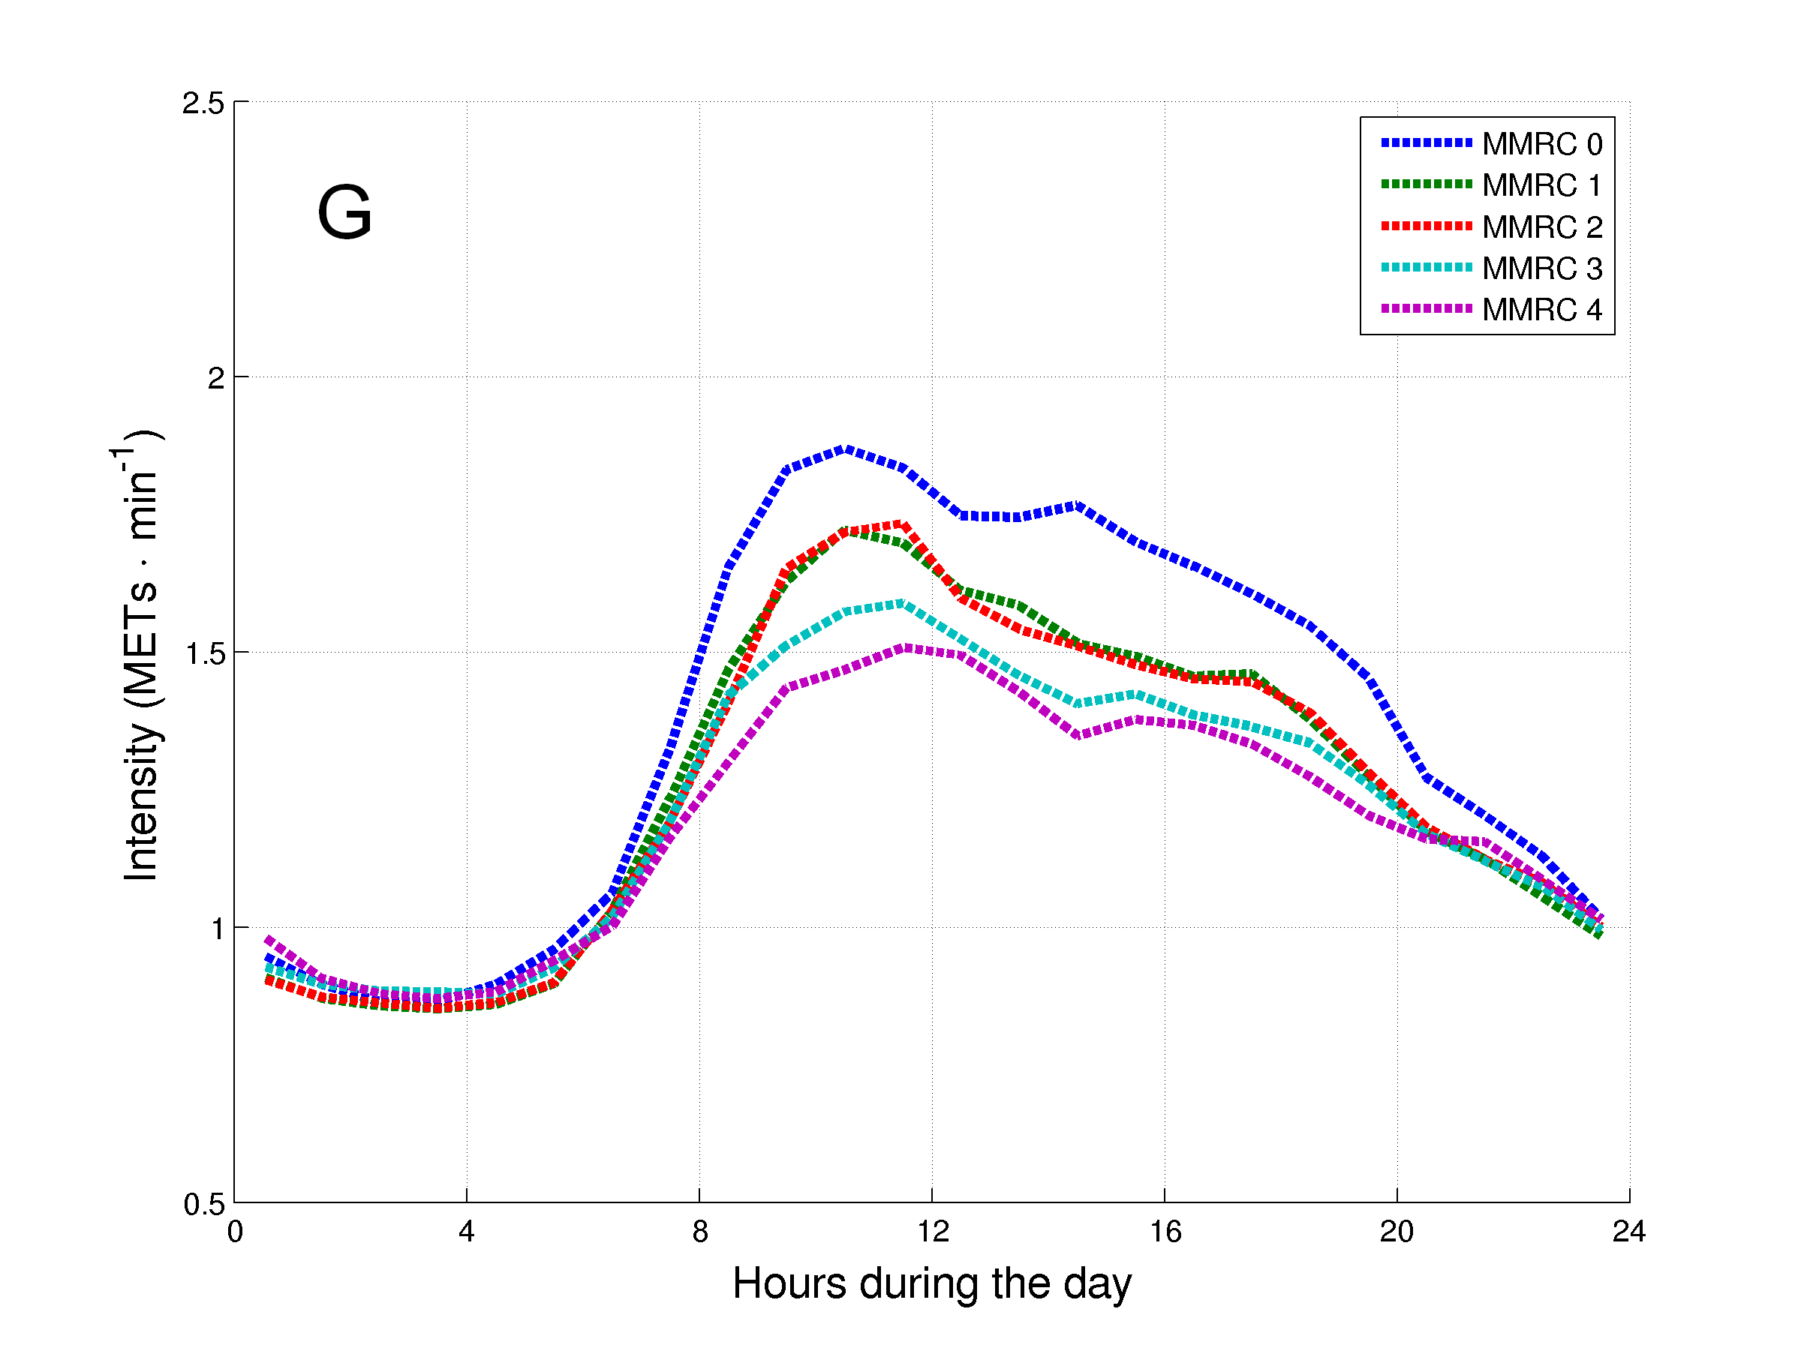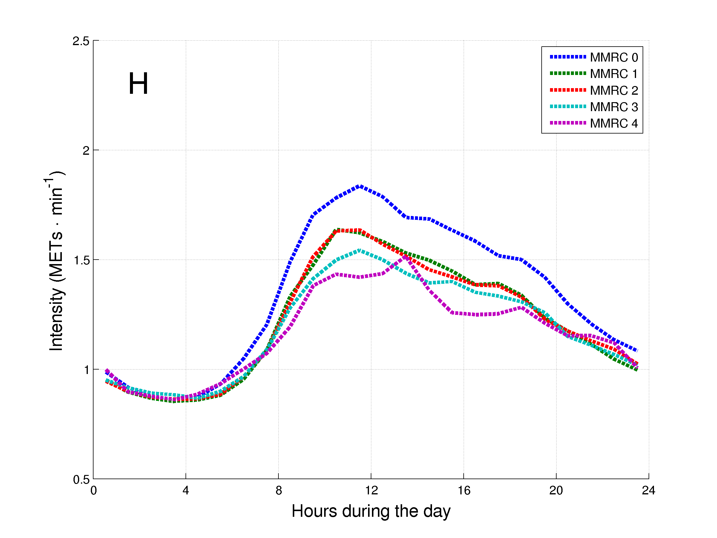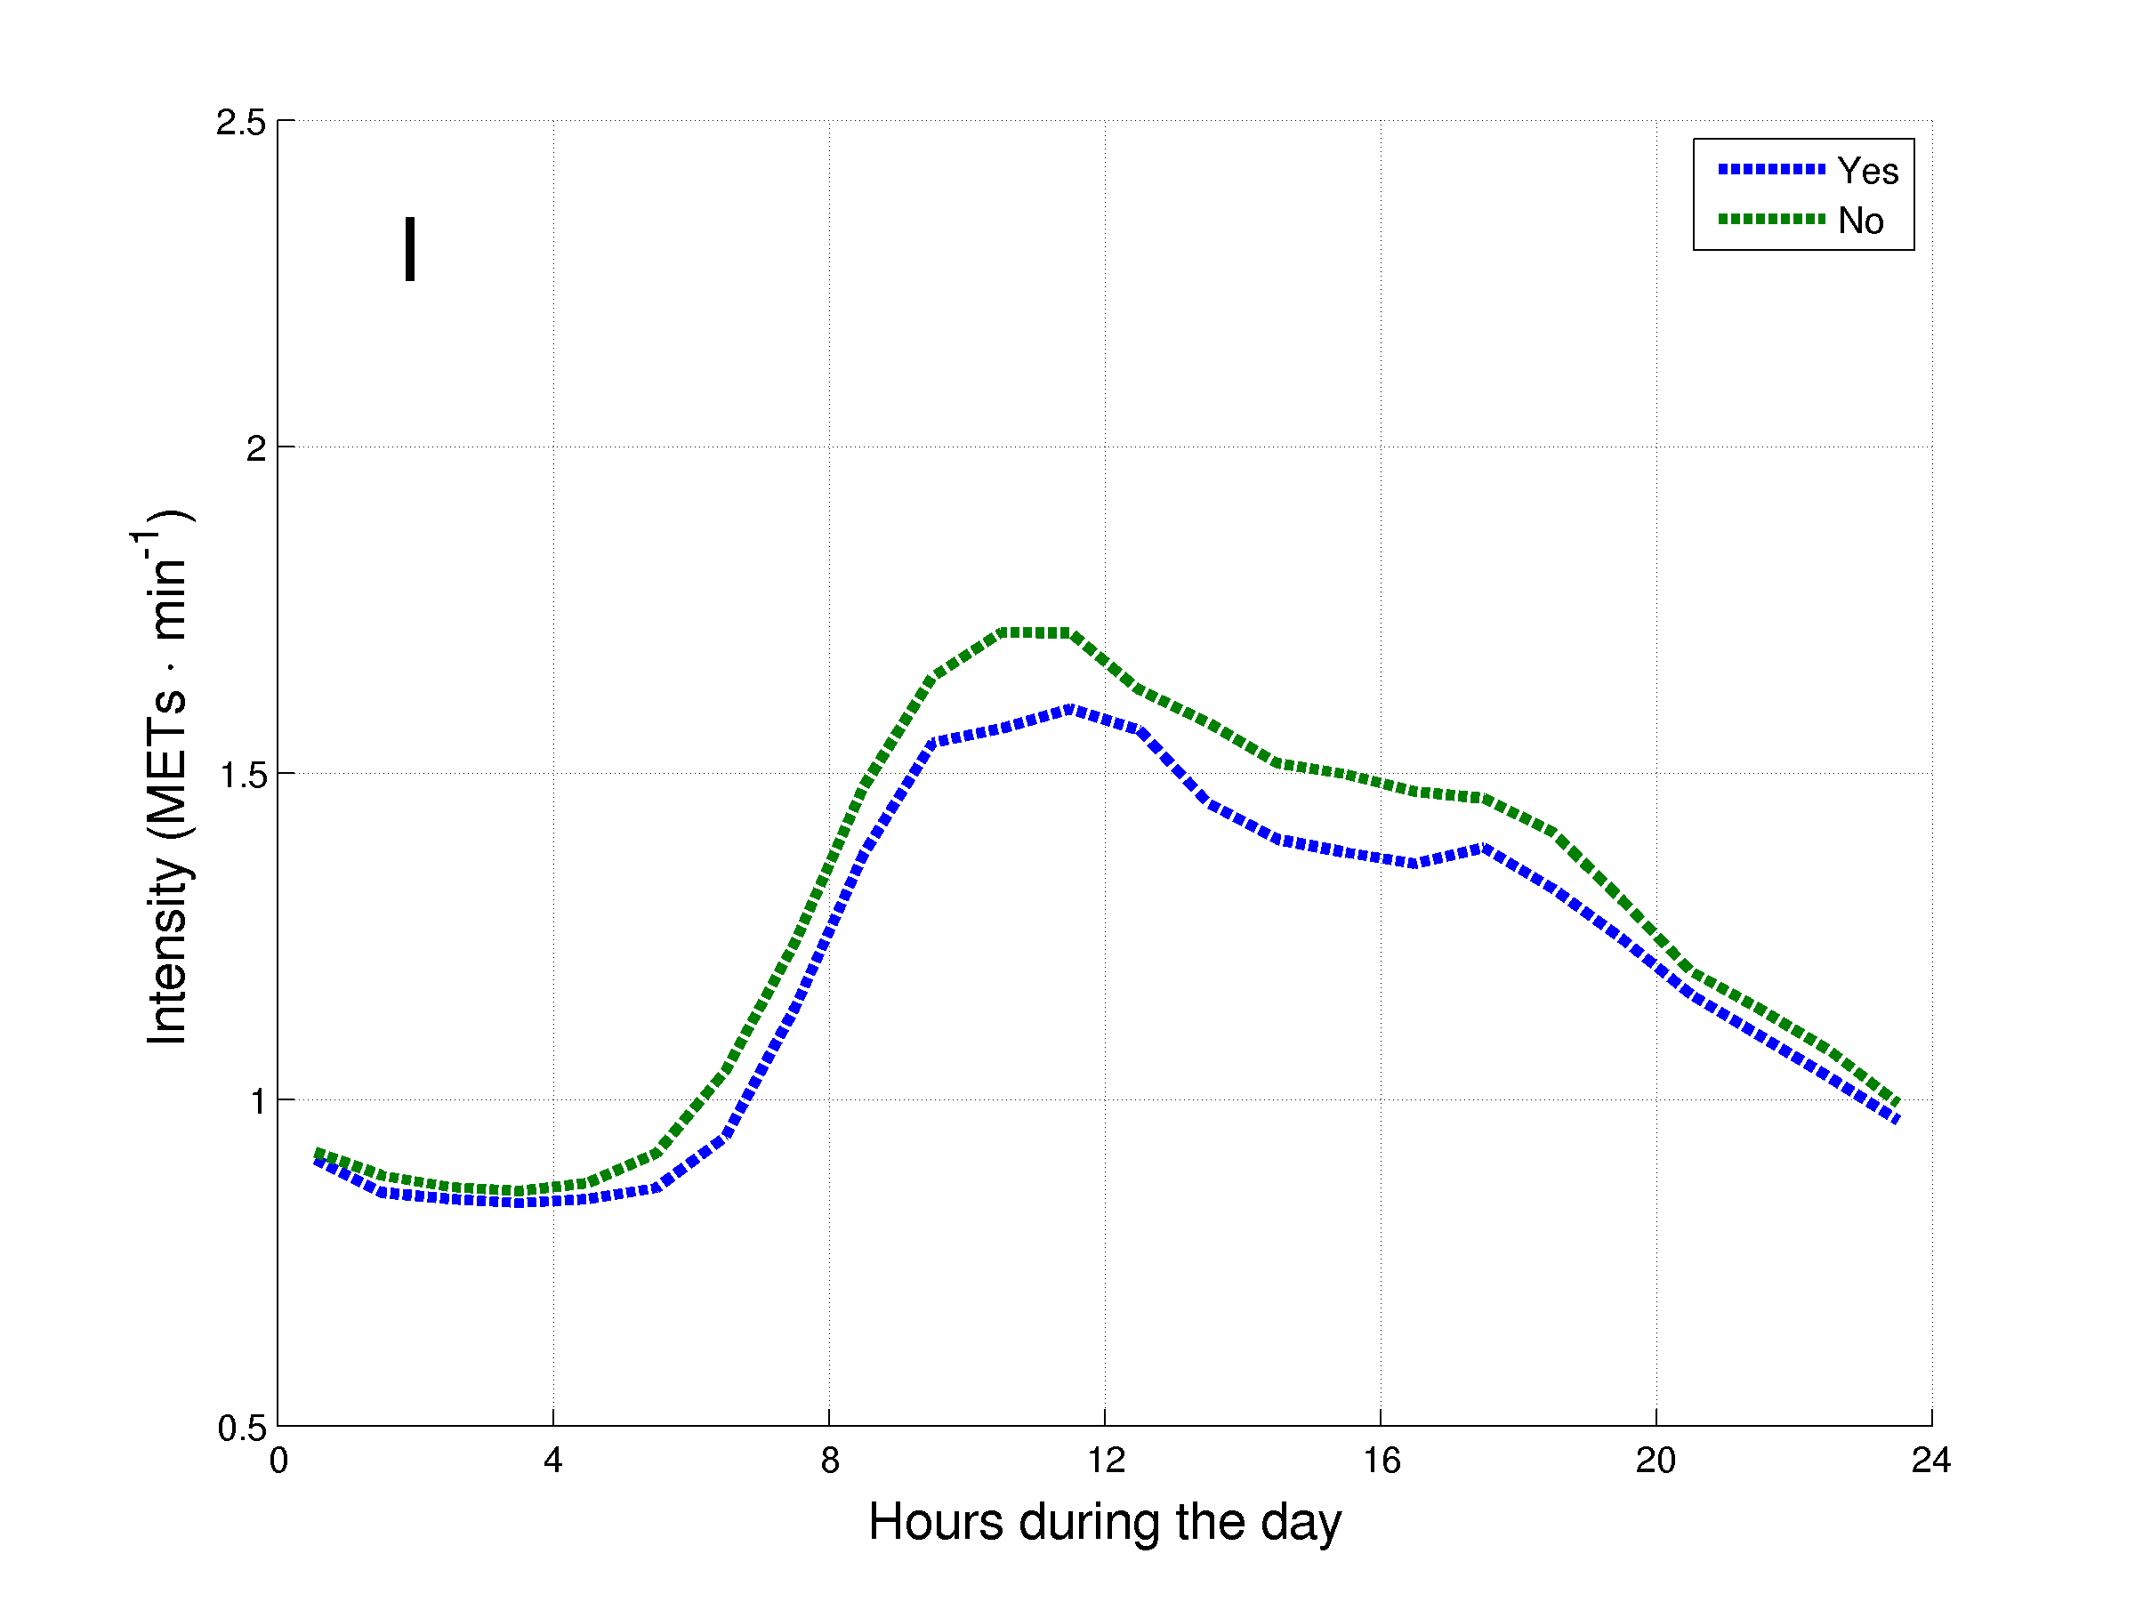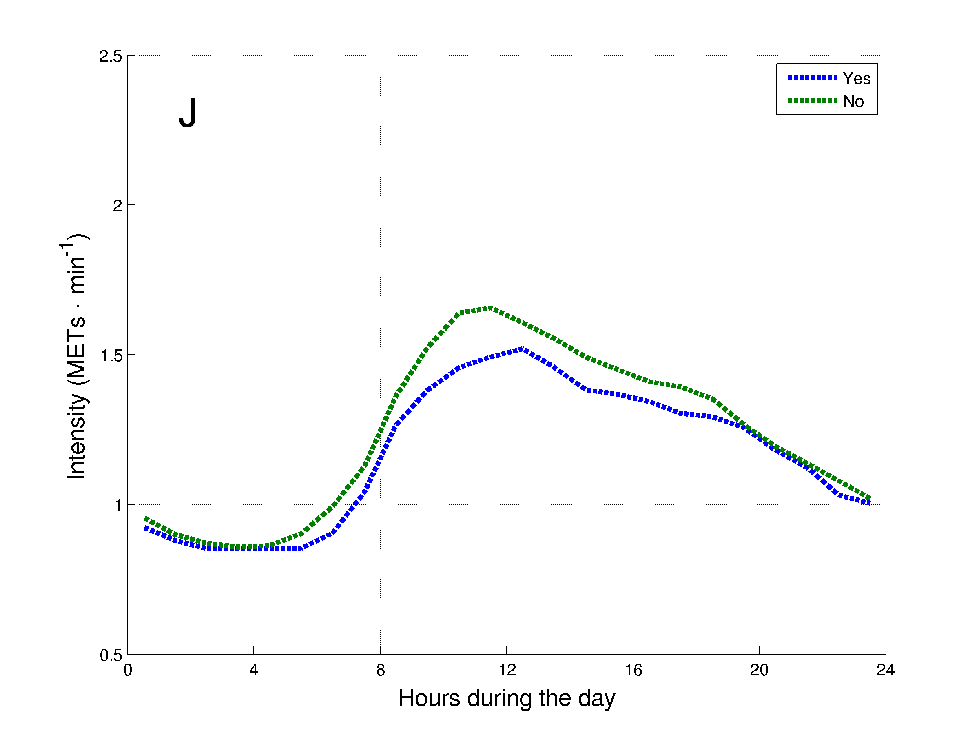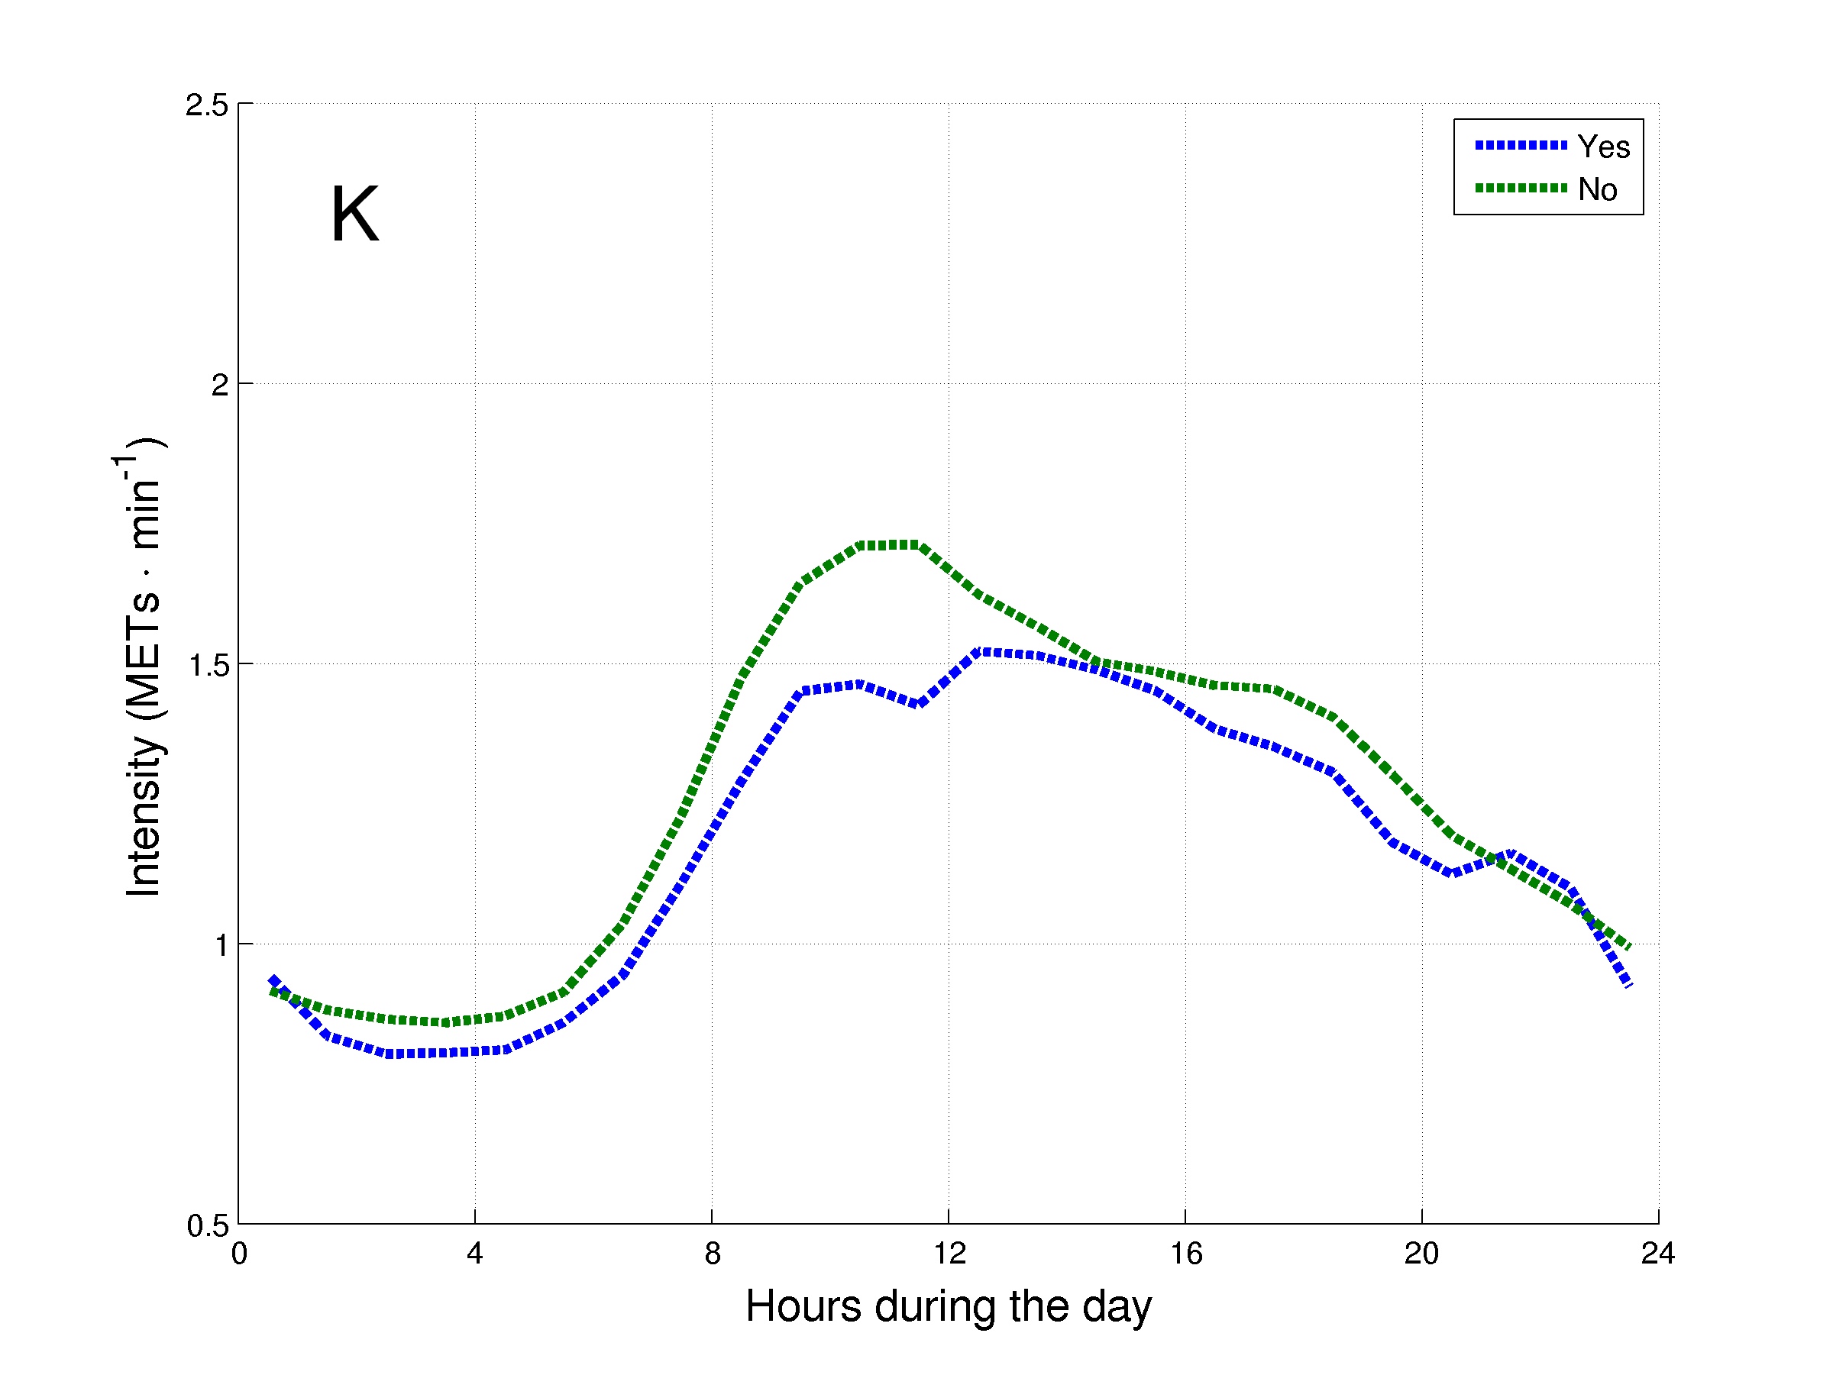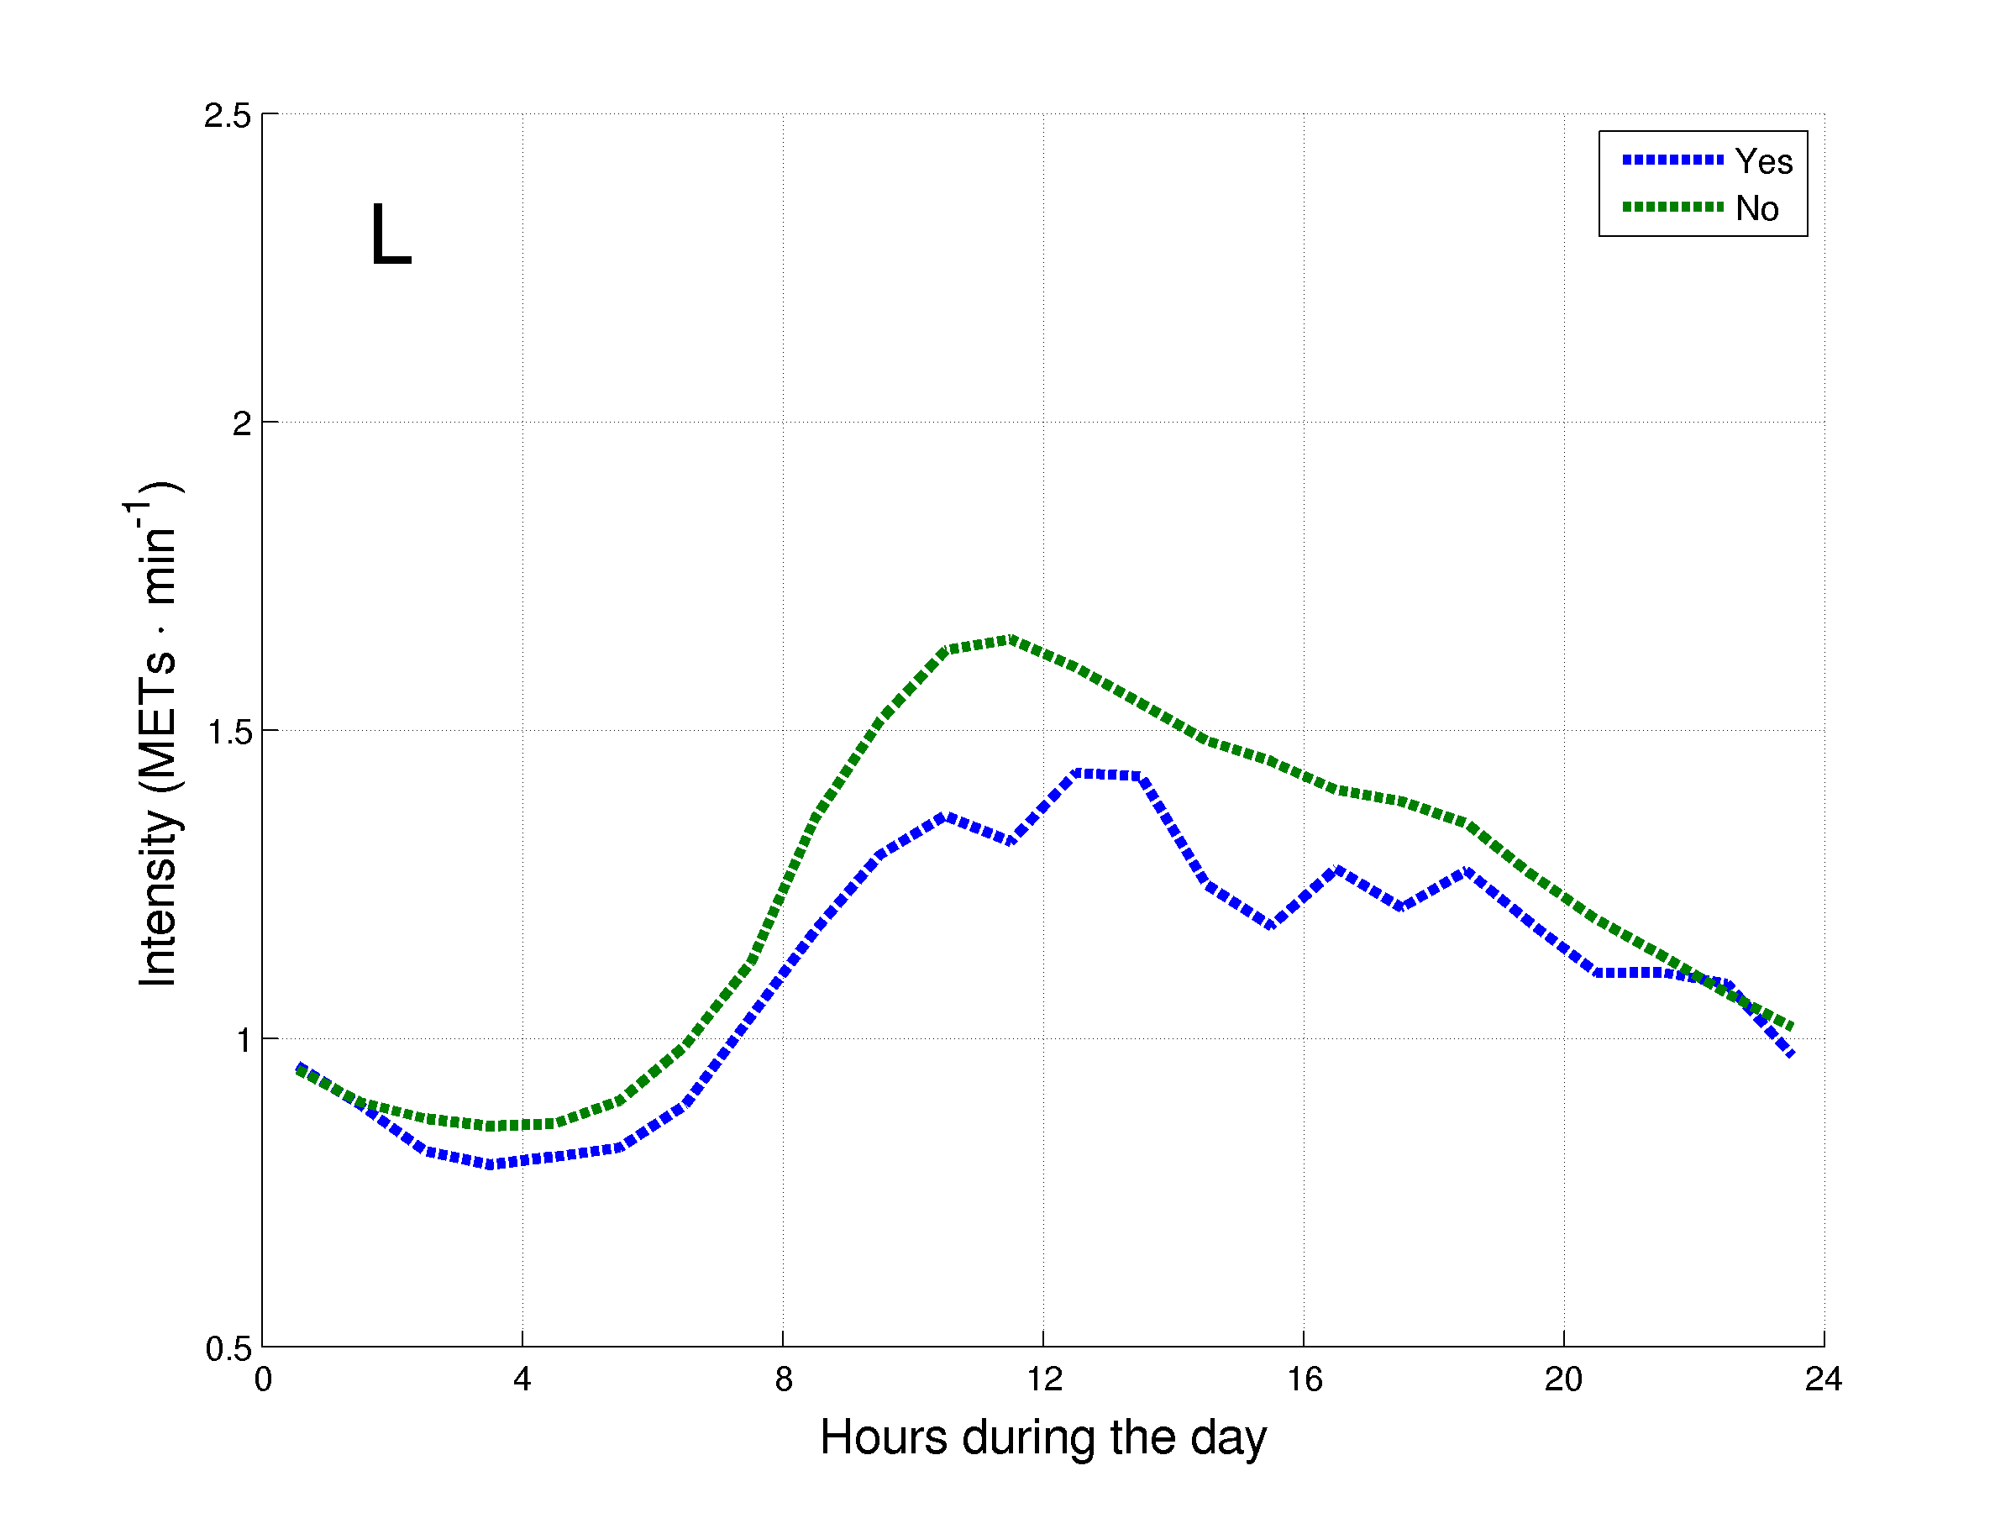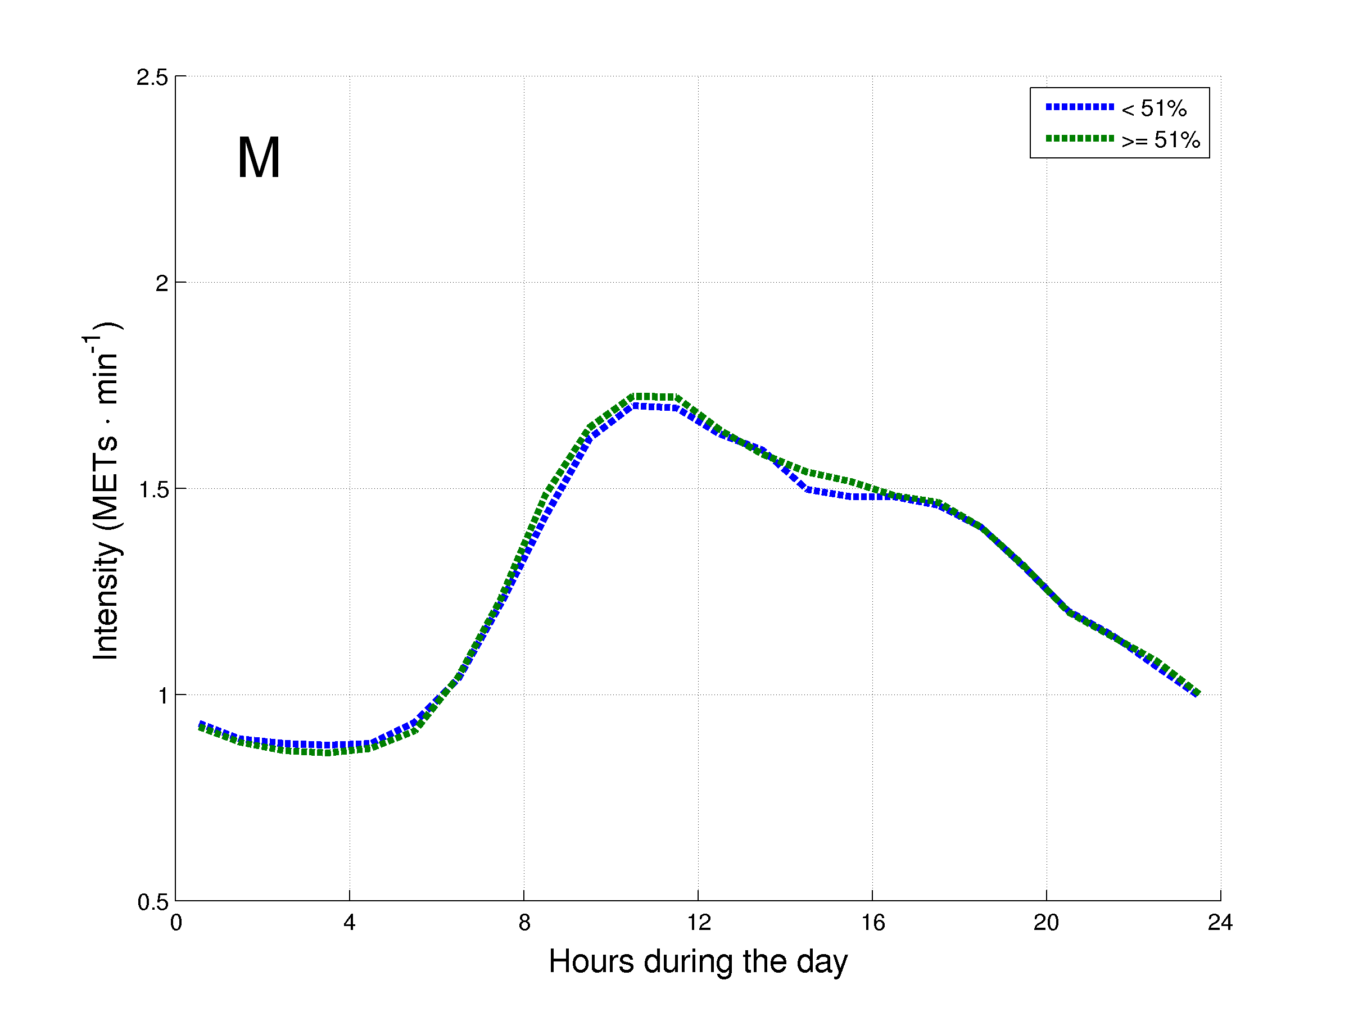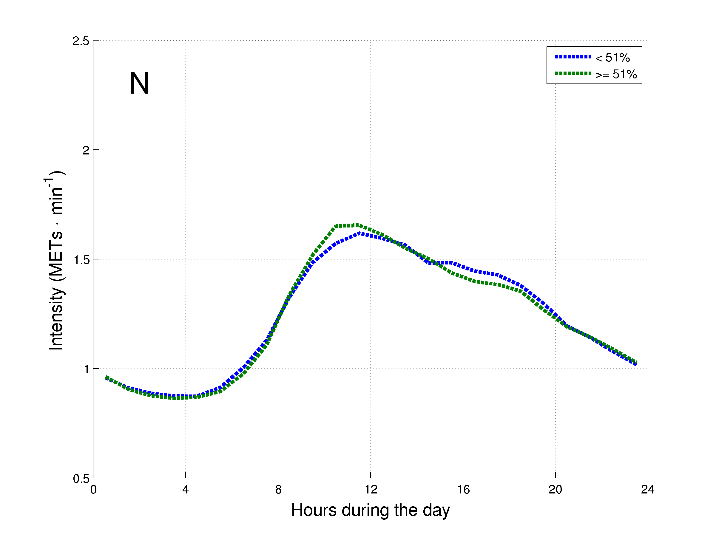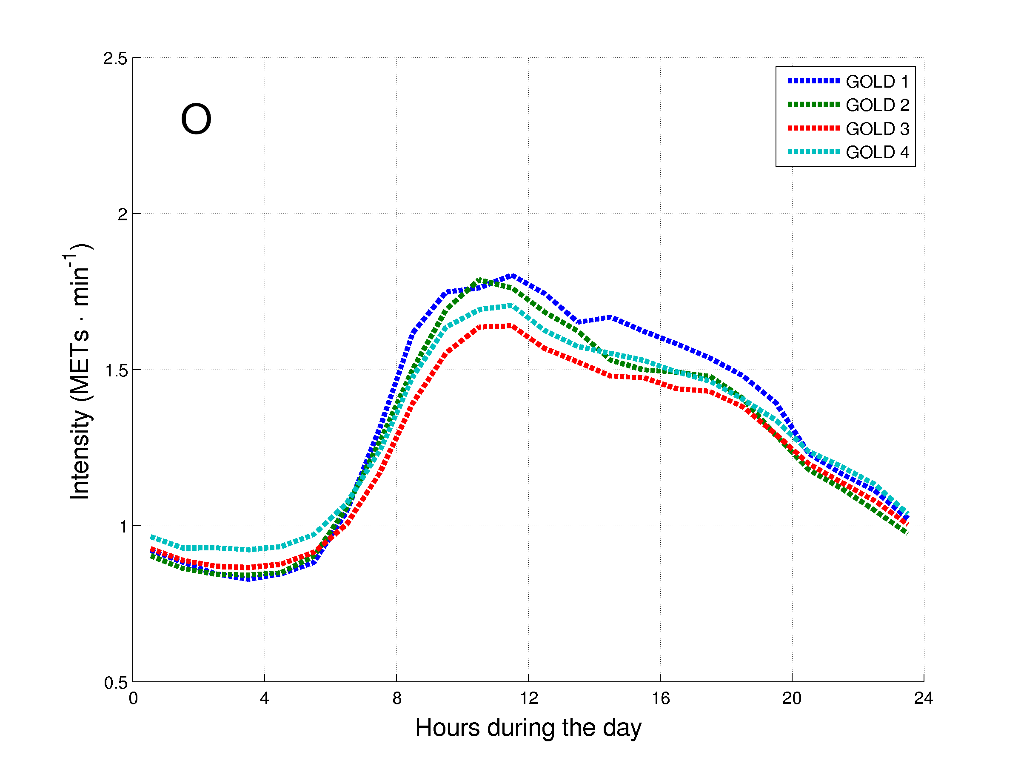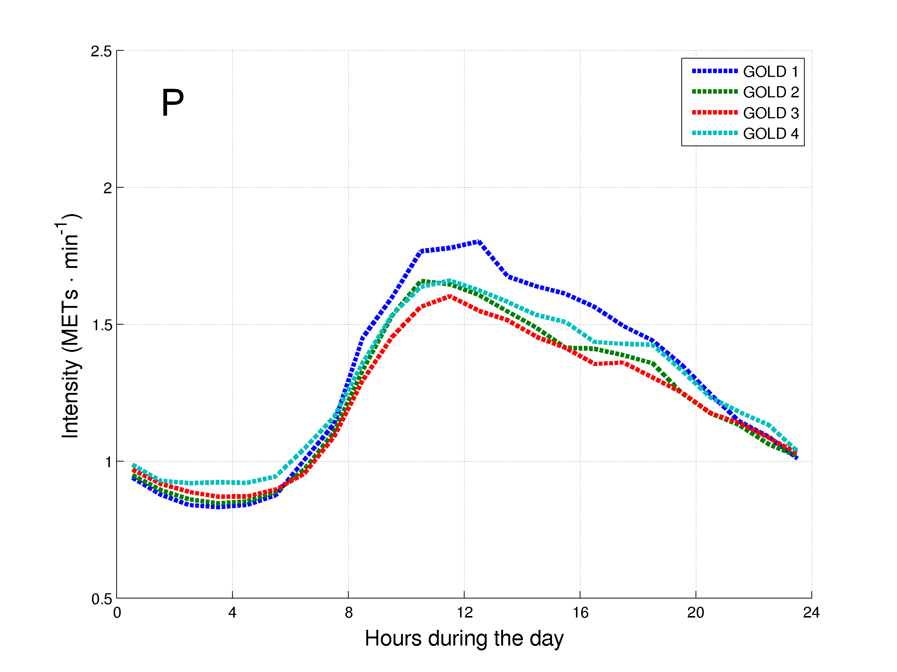
Figure 1. Daily hourly pattern of the patients with COPD after stratification for general characteristics during week (A, C, E, G, I, K, M and O) and weekend (B, D, F, H, J, L, N and P) days. The daily hourly pattern was stratified for: A and B – age groups; C and D – gender; E and F – body mass index (BMI) classification; G and H – modified Medical Research Council (mMRC) grades; I and J – long-term oxygen therapy (LTOT) use; K and L – walking aids use; M and N – diffusion capacity of the lung for carbon monoxide (DLCO) groups; and O and P – Global Initiative for Chronic Obstructive Lung Disease (GOLD) grades.
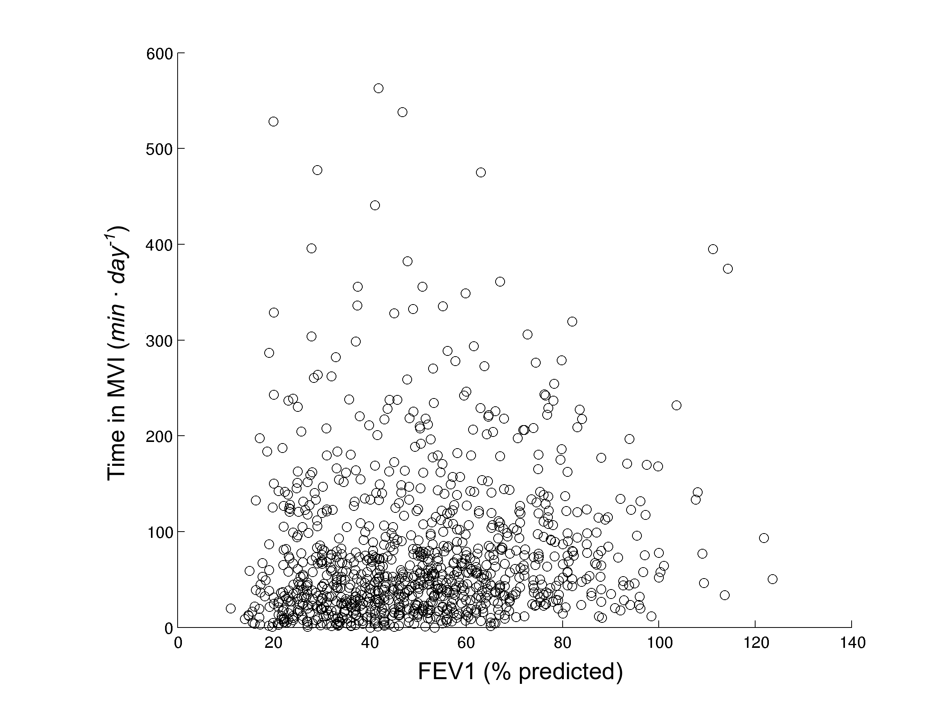
Figure 2. Correlation between the degree of airflow limitation and the daily time in MVI.

COPD versus healthy subjects
Table 3 presents the comparison of general characteristics and PA daily levels in MVI between healthy subjects and a group of matched patients with COPD. In total, 66 healthy subjects fulfilled all inclusion criteria and were included. Subjects with COPD presented worse lung function and dyspnea, as expected, but also worse levels of physical activity. The comparison of PA daily levels in VLI and LI can be found in Table E10 (online supplement). Interestingly, subjects with COPD spent more time in VLI than healthy subjects, but there was no difference when the time in LI was compared. Figure 2 presents the daily hourly pattern of the groups during week and weekend days. Both groups presented the highest intensity in the morning. The hourly pattern during week and weekend days was similar in the COPD sample, but in the sample of healthy subjects the highest intensity achieved during the day was higher in the week compared to the weekend.

TABLE 3. GENERAL CHARACTERISTICS AND PHYSICAL ACTIVITY DAILY LEVELS IN MODERATE-TO-VIGOROUS INTENSITY IN HEALTHY SUBJECTS AND MATCHED PATIENTS WITH COPD
Variable | Healthy subjects | Matched patients with COPD | P-value
General characteristics  N | 66 | 66
Age, yrs | 65 (61 – 70) | 65 (61 – 70) | 1.00
Male, % | 45 | 45 | 1.00
BMI, kg·m⁻² | 25.3 (22.9 – 28.1) | 24.9 (22.4 – 27.9) | 0.65
FEV₁, % predicted | 107 (97 – 117) | 43 (29 – 63) | <0.0001
FEV₁/FVC, % | 78 (75 – 82) | 42 (32 – 54) | <0.0001
mMRC dyspnea grade, points* | 0 (0 – 0) | 2 (1 – 3) | <0.0001
Physical activity levels in MVI  Time, min∙day⁻¹ | 101 (57 – 163) | 47 (30 – 95) | <0.0001
EE, METs-min∙day⁻¹ | 461 (271 – 797) | 213 (123 – 435) | <0.0001
Time in ≥2-min bouts, min∙day⁻¹ | 82 (38 – 138) | 37 (15 – 83) | <0.0001
Time in ≥10-min bouts, min∙day⁻¹ | 29 (10 – 73) | 6 (0 – 20) | <0.0001
Frequency of ≥2-min bouts, bouts∙day⁻¹ | 17 (10 – 25) | 9 (5 – 17) | <0.0001
Frequency of ≥10-min bouts, bouts∙day⁻¹ | 2 (1 – 4) | 0 (0 – 1) | <0.0001
Average duration of ≥2-min bouts, min∙bout⁻¹ | 5 (4 – 7) | 4 (3 – 5) | <0.0001
Average duration of ≥10-min bouts, min∙bout⁻¹ | 16 (13 – 21) | 12 (0 – 14) | <0.0001
EE in ≥2-min bouts, METs-min∙day⁻¹ | 362 (212 – 712) | 164 (65 – 376) | <0.0001
EE in ≥10-min bouts, METs-min∙day⁻¹ | 107 (47 – 417) | 23 (0 – 121) | <0.0001
Data expressed as median (interquartile range). See Table 2 for definition of abbreviations. *Data missing for 18 healthy subjects and 7 patients with COPD.
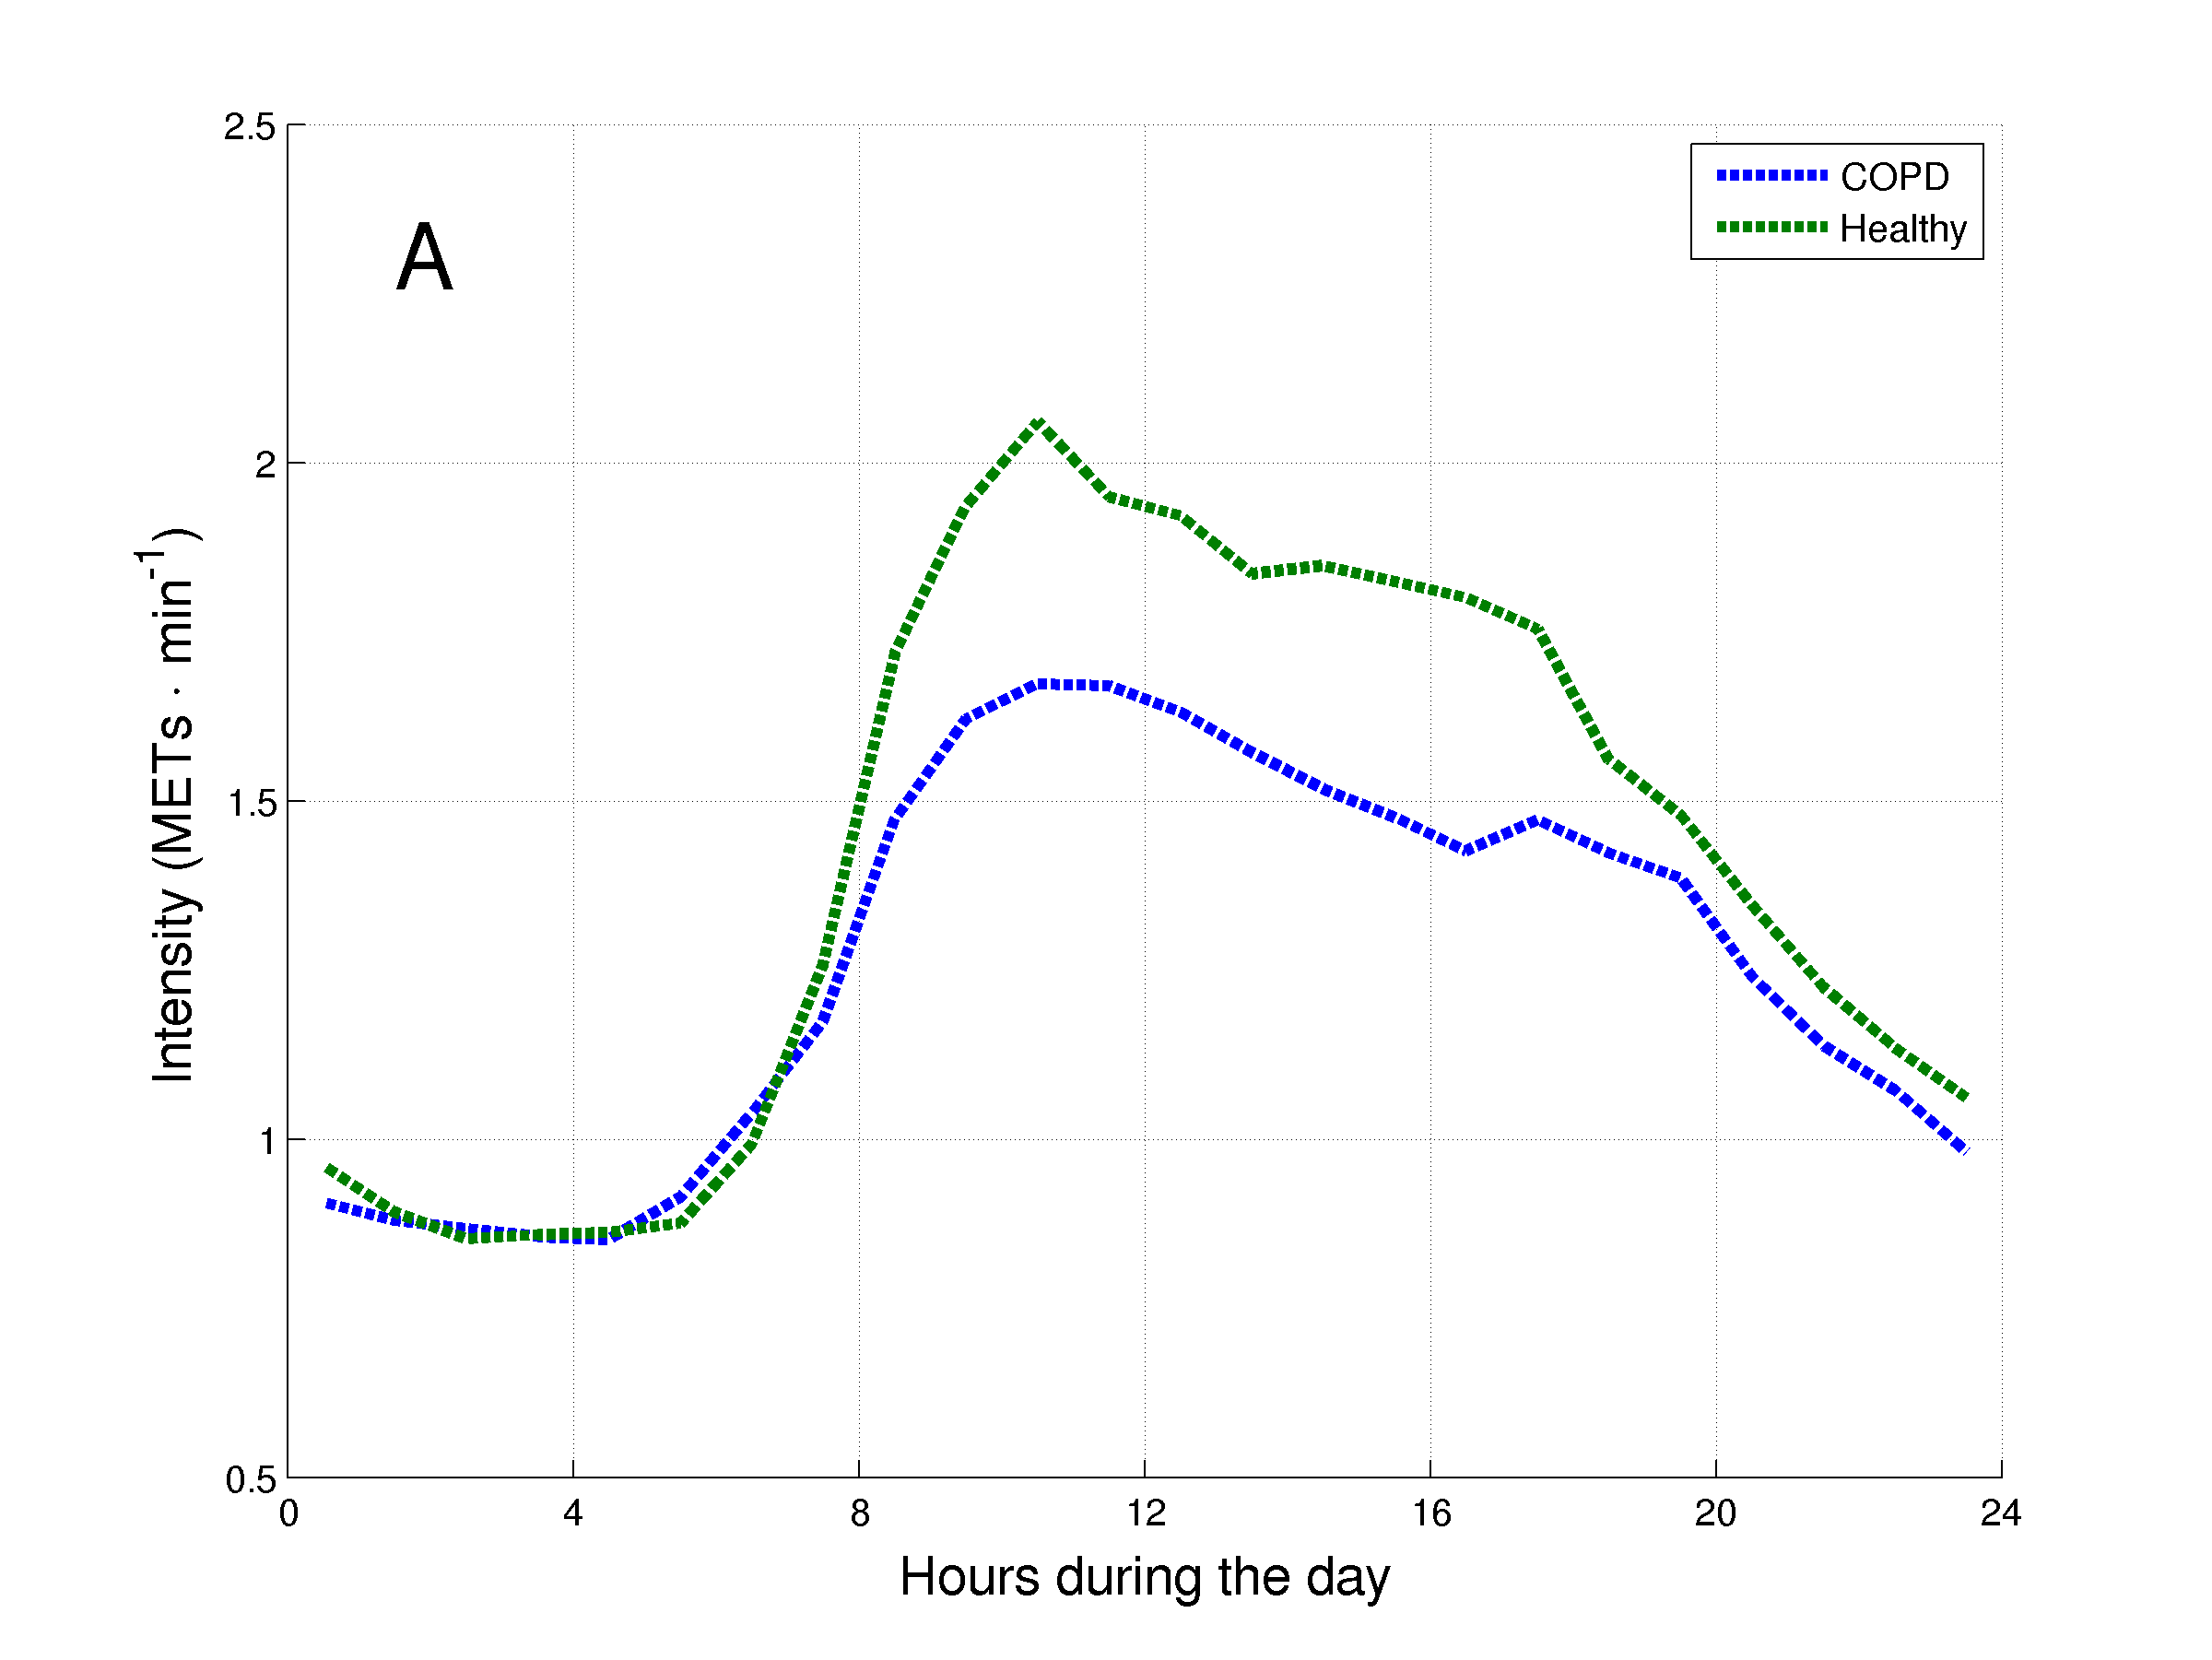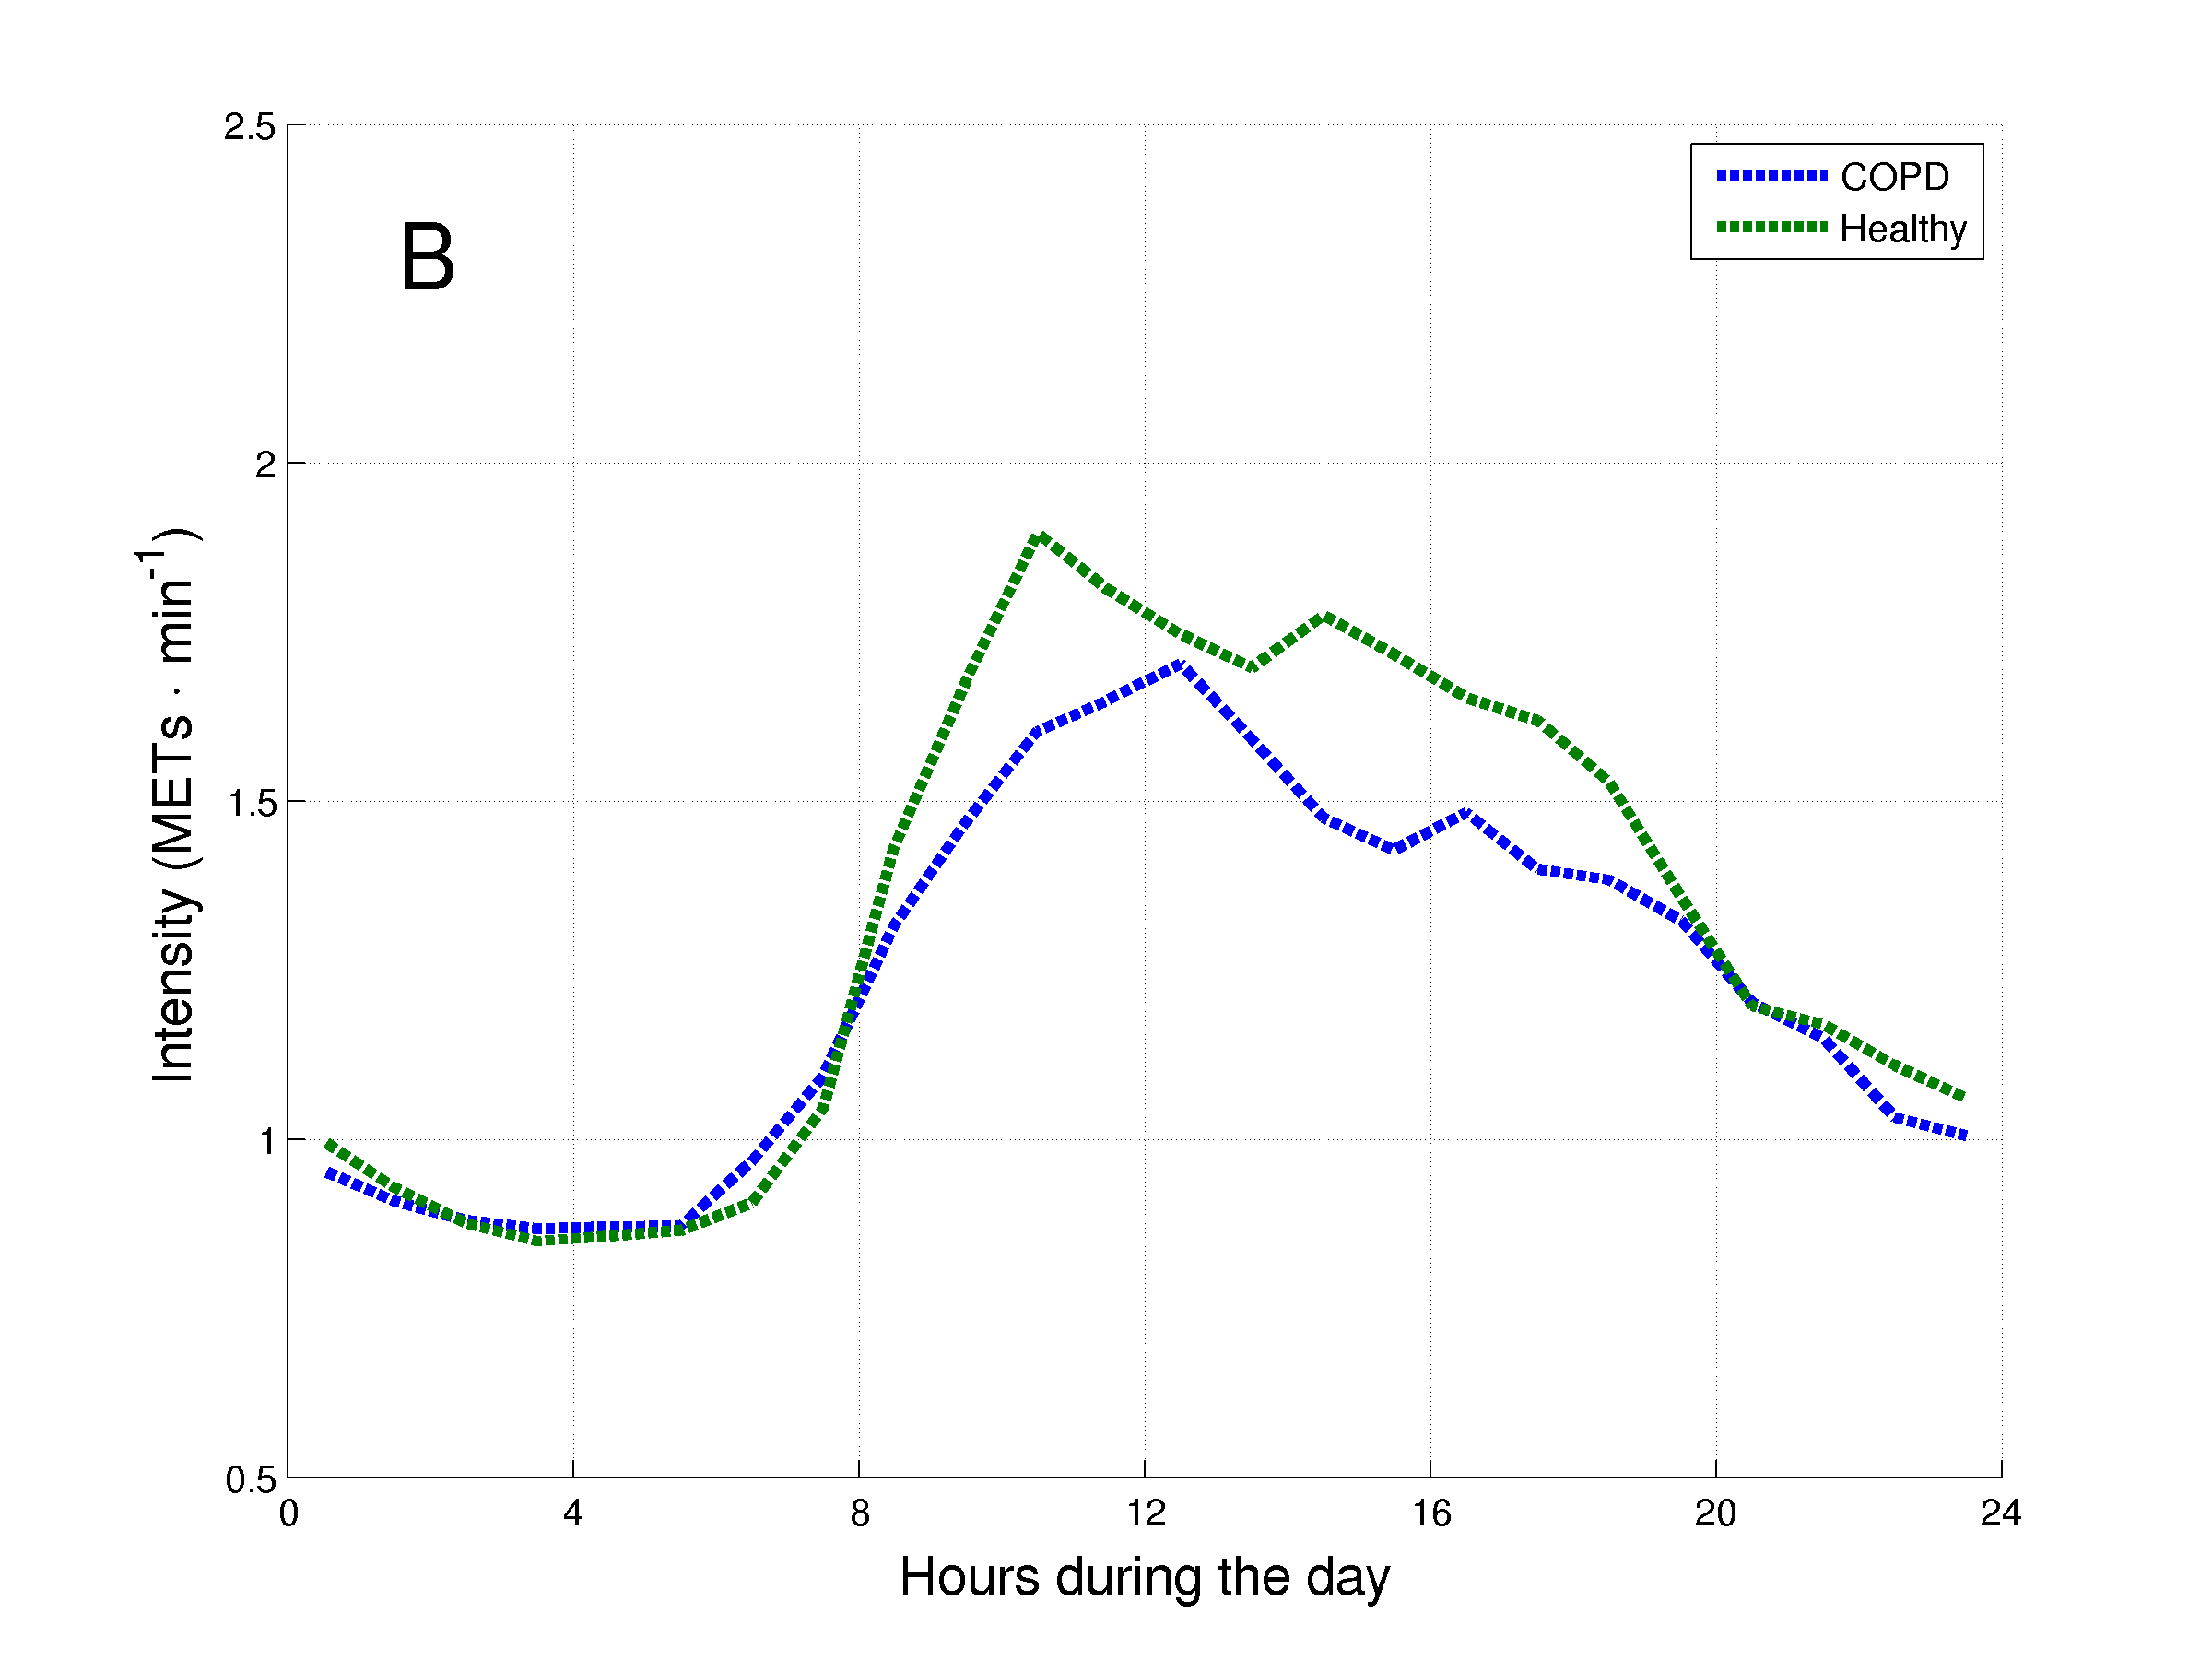
Figure 2. Daily hourly pattern of healthy subjects and matched patients with COPD during week (A) and weekend (B) days.

Cluster analysis of physical activity daily levels
Five clusters were identified based on components from the PCA analysis (Figure 3). The most relevant variables of each component can be found in the online supplement. Table 4 presents the general characteristics and PA daily levels in MVI of the clusters identified. Cluster 2 presented a lower age compared to clusters 1 and 4, while cluster 1 presented a higher BMI than the other clusters and a lower FEV₁ than clusters 2 and 3. Regarding physical activity daily levels, in general cluster 1 was the least active cluster and cluster 5 the most active. The levels of PA in VLI and LI can be found in Table E11 (online supplement).

The hourly pattern of the clusters during week and weekend days can be found in Figure 4. In all clusters the highest intensity during the day occurred in the morning. In general, the pattern during week and weekend days was similar, but the highest intensity during the day tended to be lower in the weekend. This phenomenon was more pronounced in Cluster 5 and less pronounced in Cluster 1.

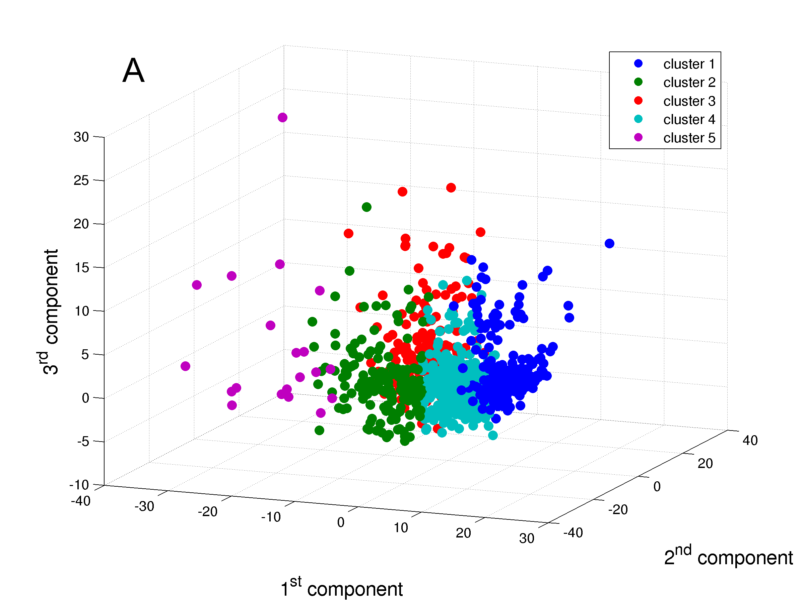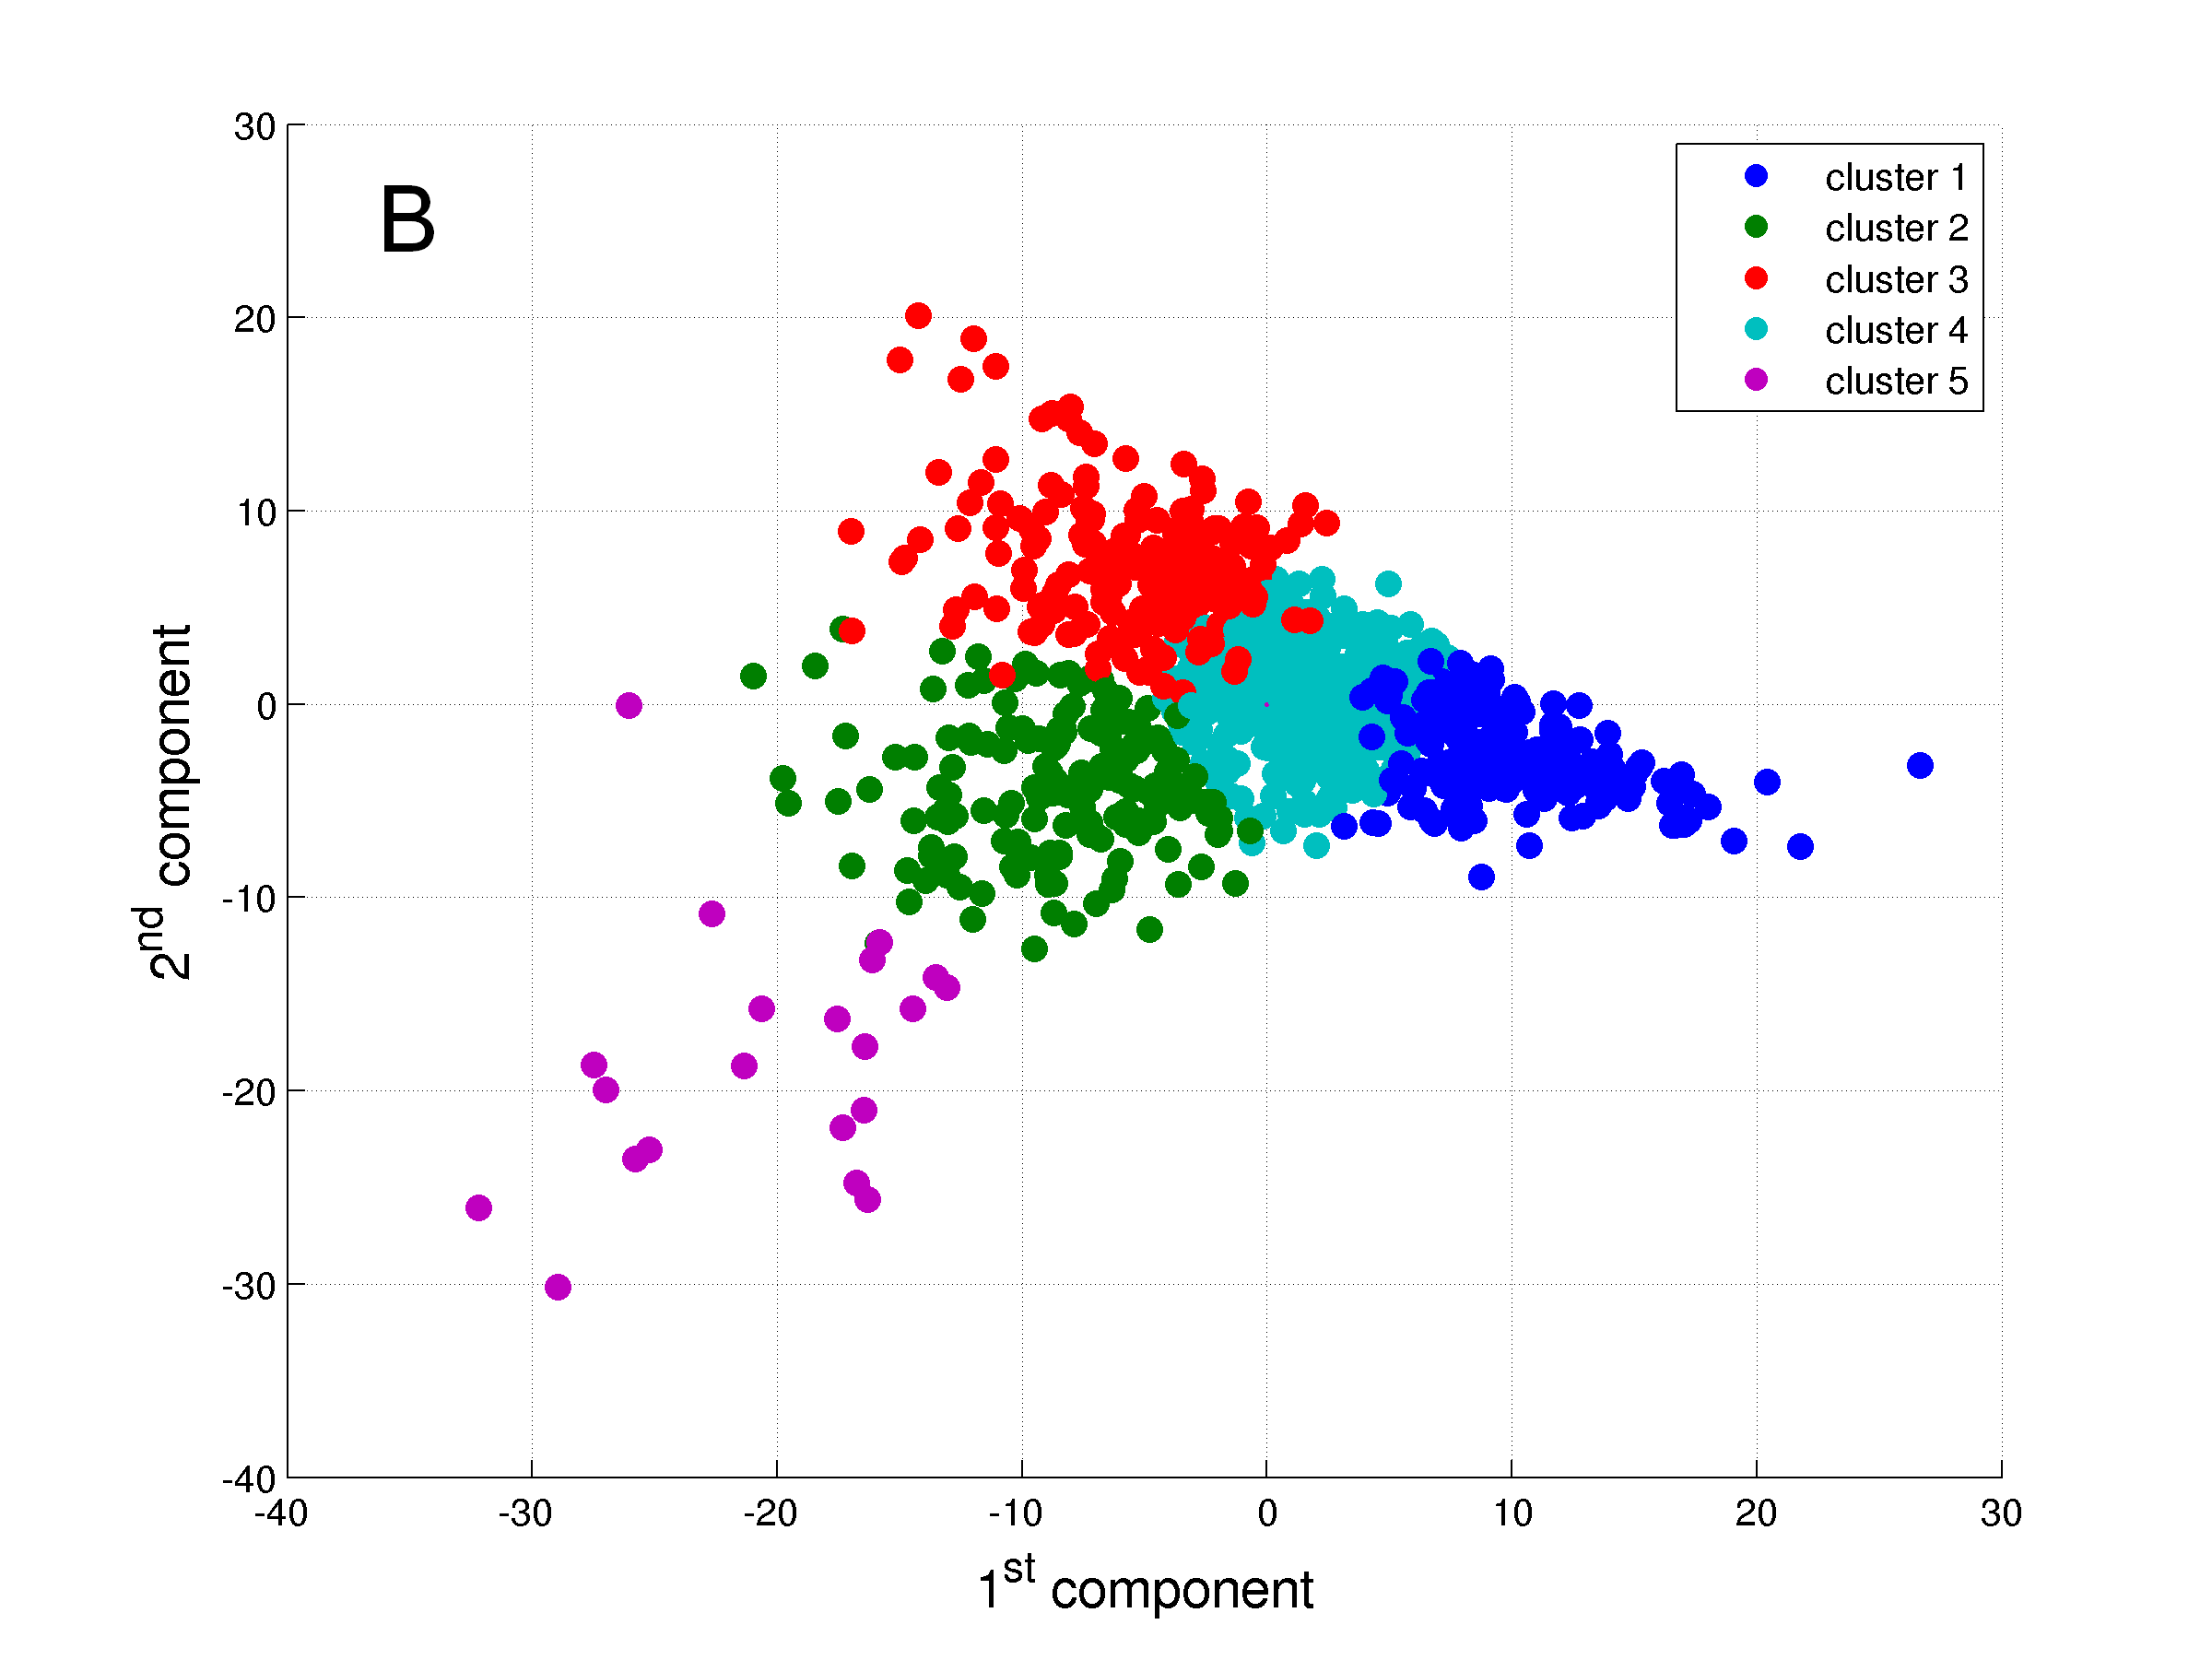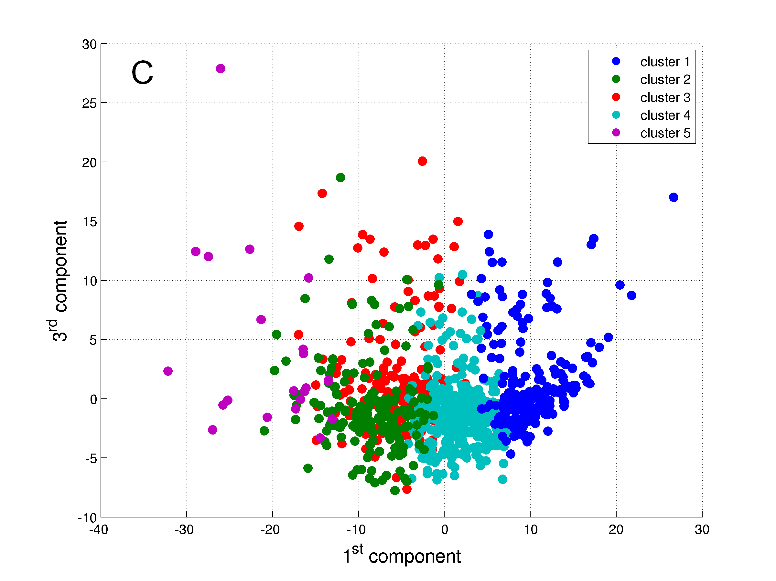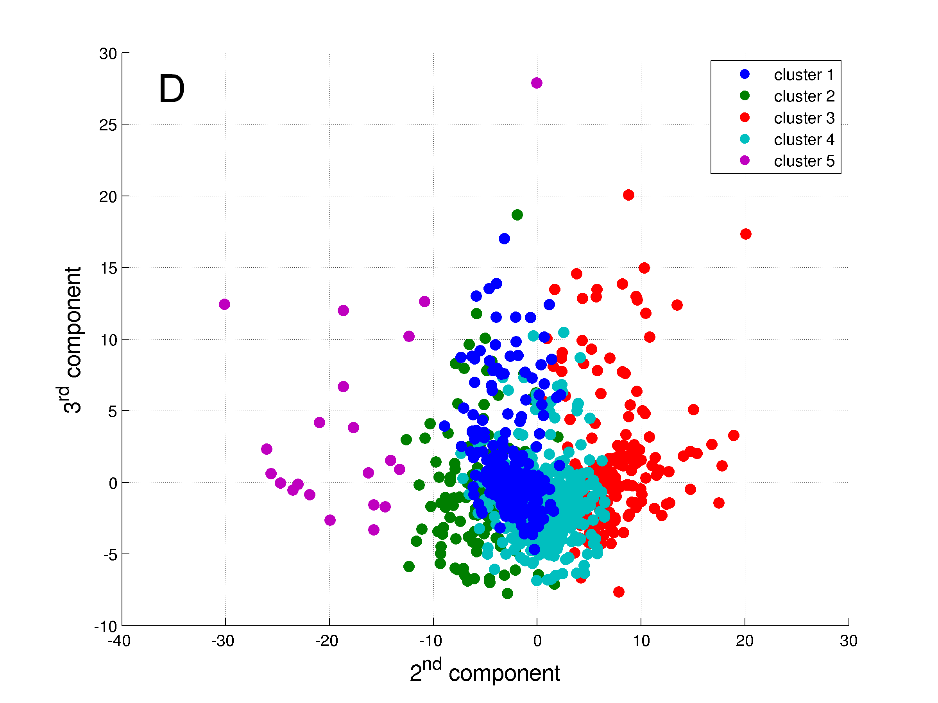
Figure 3. The five clusters identified. A: Graph in 3 dimensions presenting axes X, Y and Z; B: Graph in 2 dimensions presenting axes X and Y; C: Graph in 2 dimensions presenting axes X and Z; and D: Graph in 2 dimensions presenting axes Y and Z.
TABLE 4. GENERAL CHARACTERISTICS AND PHYSICAL ACTIVITY DAILY LEVELS OF THE CLUSTERS OF PATIENTS WITH COPD
Variable | Cluster 1 | Cluster 2 | Cluster 3 | Cluster 4 | Cluster 5 | P-value
General characteristics  N | 216 | 165 | 184 | 415 | 21
Age, yrs | 68 (62 – 74) | 63 (58 – 70)† | 67 (60 – 72) | 67 (61 – 72)‡ | 63 (56 – 68) | <0.0001
Male, % | 67 | 76 | 51 | 67 | 67 | 0.32
BMI, kg·m⁻² | 30.4 (26.5 – 34.7) | 23.1 (20.3 – 26.8)† | 24.9 (22.2 – 27.4)† | 25.7 (22.6 – 29.0)†,‡ | 22.5 (18.3 – 30.9)† | <0.0001
FEV₁, % predicted | 44 (32 – 58) | 50 (36 – 68)† | 57 (41 – 71)† | 48 (34 – 61)§ | 51 (39 – 70) | <0.0001
FEV₁/FVC, % | 43 (34 – 55) | 47 (36 – 57) | 50 (38 – 61)† | 44 (34 – 55)§ | 49 (38 – 64) | 0.002
mMRC dyspnea grade, points* | 2 (1 – 3) | 1 (0 – 3) | 1 (1 – 2) | 2 (1 – 3) | 1 (0 – 2) | <0.0001
Physical activity levels in MVI  Time, min∙day⁻¹ | 15 (7 – 27) | 166 (136 – 219)† | 68 (43 – 96)†,‡ | 48 (30 – 70)†,‡,§ | 361 (332 – 458)^{†,§,ǁ} | <0.0001
EE, METs-min∙day⁻¹ | 90 (40 – 192) | 805 (616 – 1134)† | 327 (198 – 527)†,‡ | 235 (138 – 349)†,‡,§ | 2693 (1694 – 5886)^{†,§,ǁ} | <0.0001
Time in ≥2-min bouts, min∙day⁻¹ | 9 (4 – 19) | 145 (118 – 190)† | 51 (29 – 72)†,‡ | 36 (20 – 54)†,‡,§ | 336 (293 – 433)^{†,§,ǁ} | <0.0001
Time in ≥10-min bouts, min∙day⁻¹ | 0 (0 – 3) | 60 (38 – 91)† | 9 (3 – 18)†,‡ | 5 (0 – 14)†,‡,§ | 209 (161 – 317)^{†,§,ǁ} | <0.0001
Frequency of ≥2-min bouts, bouts∙day⁻¹ | 3 (1 – 5) | 26 (20 – 33)† | 13 (8 – 17)†,‡ | 9 (6 – 13)†,‡,§ | 41 (35 – 52)^{†,§,ǁ} | <0.0001
Frequency of ≥10-min bouts, bouts∙day⁻¹ | 0 (0 – 0) | 3 (2 – 5)† | 1 (0 – 1)†,‡ | 0 (0 – 1)†,‡,§ | 10 (8 – 13)^{†,§,ǁ} | <0.0001
Average duration of ≥2-min bouts, min∙bout⁻¹ | 3 (2 – 4) | 6 (5 – 7)† | 4 (3 – 5)†,‡ | 4 (3 – 5)†,‡ | 8 (7 – 11)^{†,§,ǁ} | <0.0001
Average duration of ≥10-min bouts, min∙bout⁻¹ | 0 (0 – 11) | 17 (15 – 21)† | 13 (10 – 16)†,‡ | 12 (0 – 14)†,‡,§ | 20 (17 – 25)^{†,§,ǁ} | <0.0001
EE in ≥2-min bouts, METs-min∙day⁻¹ | 56 (20 – 123) | 704 (544 – 992)† | 251 (146 – 392)†,‡ | 173 (92 – 280)†,‡,§ | 2583 (1589 – 5348)^{†,§,ǁ} | <0.0001
EE in ≥10-min bouts, METs-min∙day⁻¹ | 0 (0 – 20) | 300 (171 – 513)† | 47 (13 – 105)†,‡ | 25 (0 – 70)†,‡,§ | 1635 (1102 – 2590)^{†,§,ǁ} | <0.0001
Data expressed as median (interquartile range). See Table 2 for definition of abbreviations. *Data missing for 18 subjects in Cluster 1, 39 subjects in Cluster 2, 25 subjects in Cluster 3, 48 subjects in Cluster 4, and 3 subjects in Cluster 5. PR; †P<0.05 vs Cluster 1; ‡P<0.05 vs Cluster 2; §P<0.05 vs Cluster 3; ^{ǁ}P<0.05 vs Cluster 4.
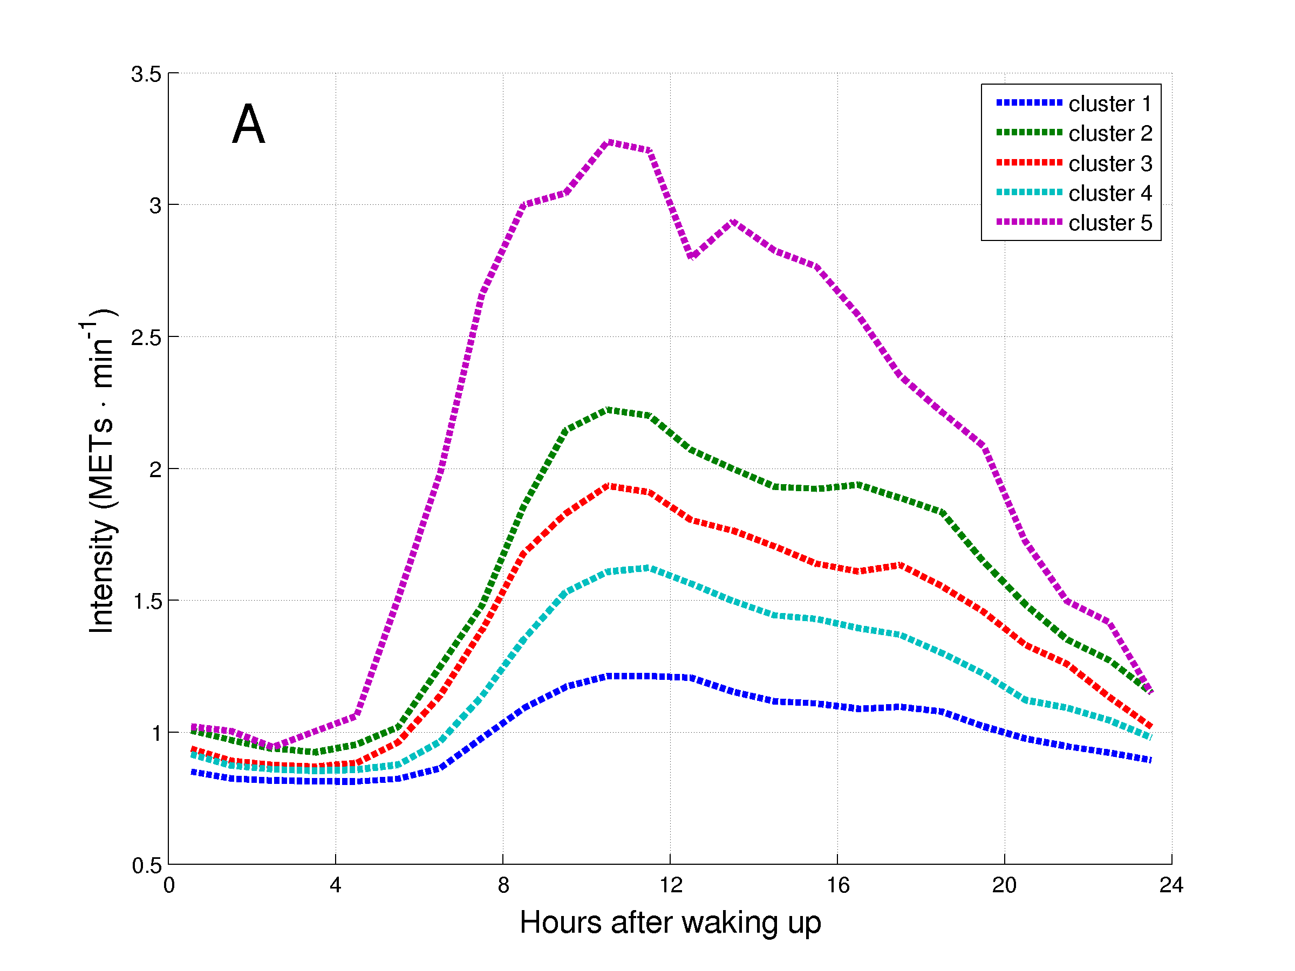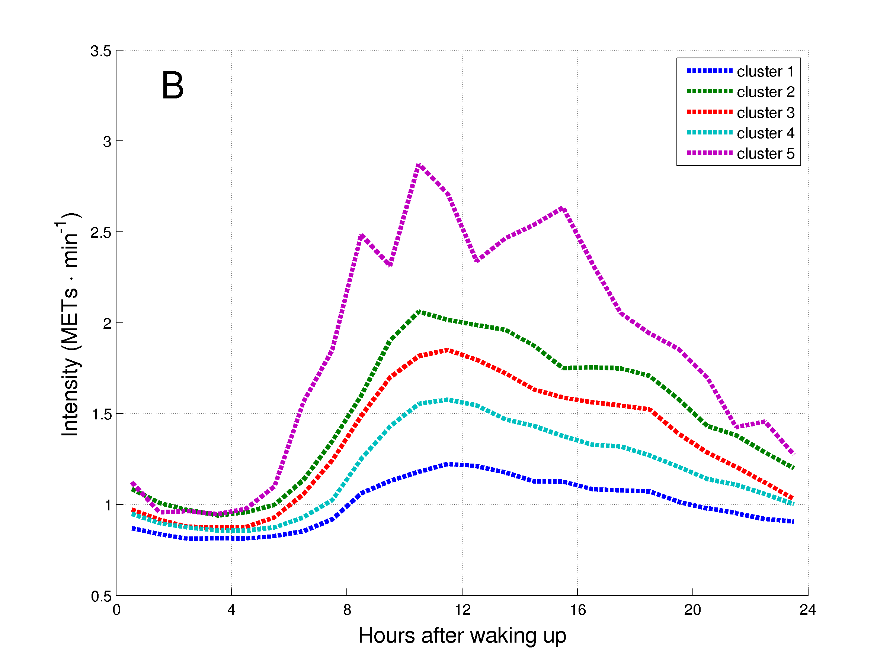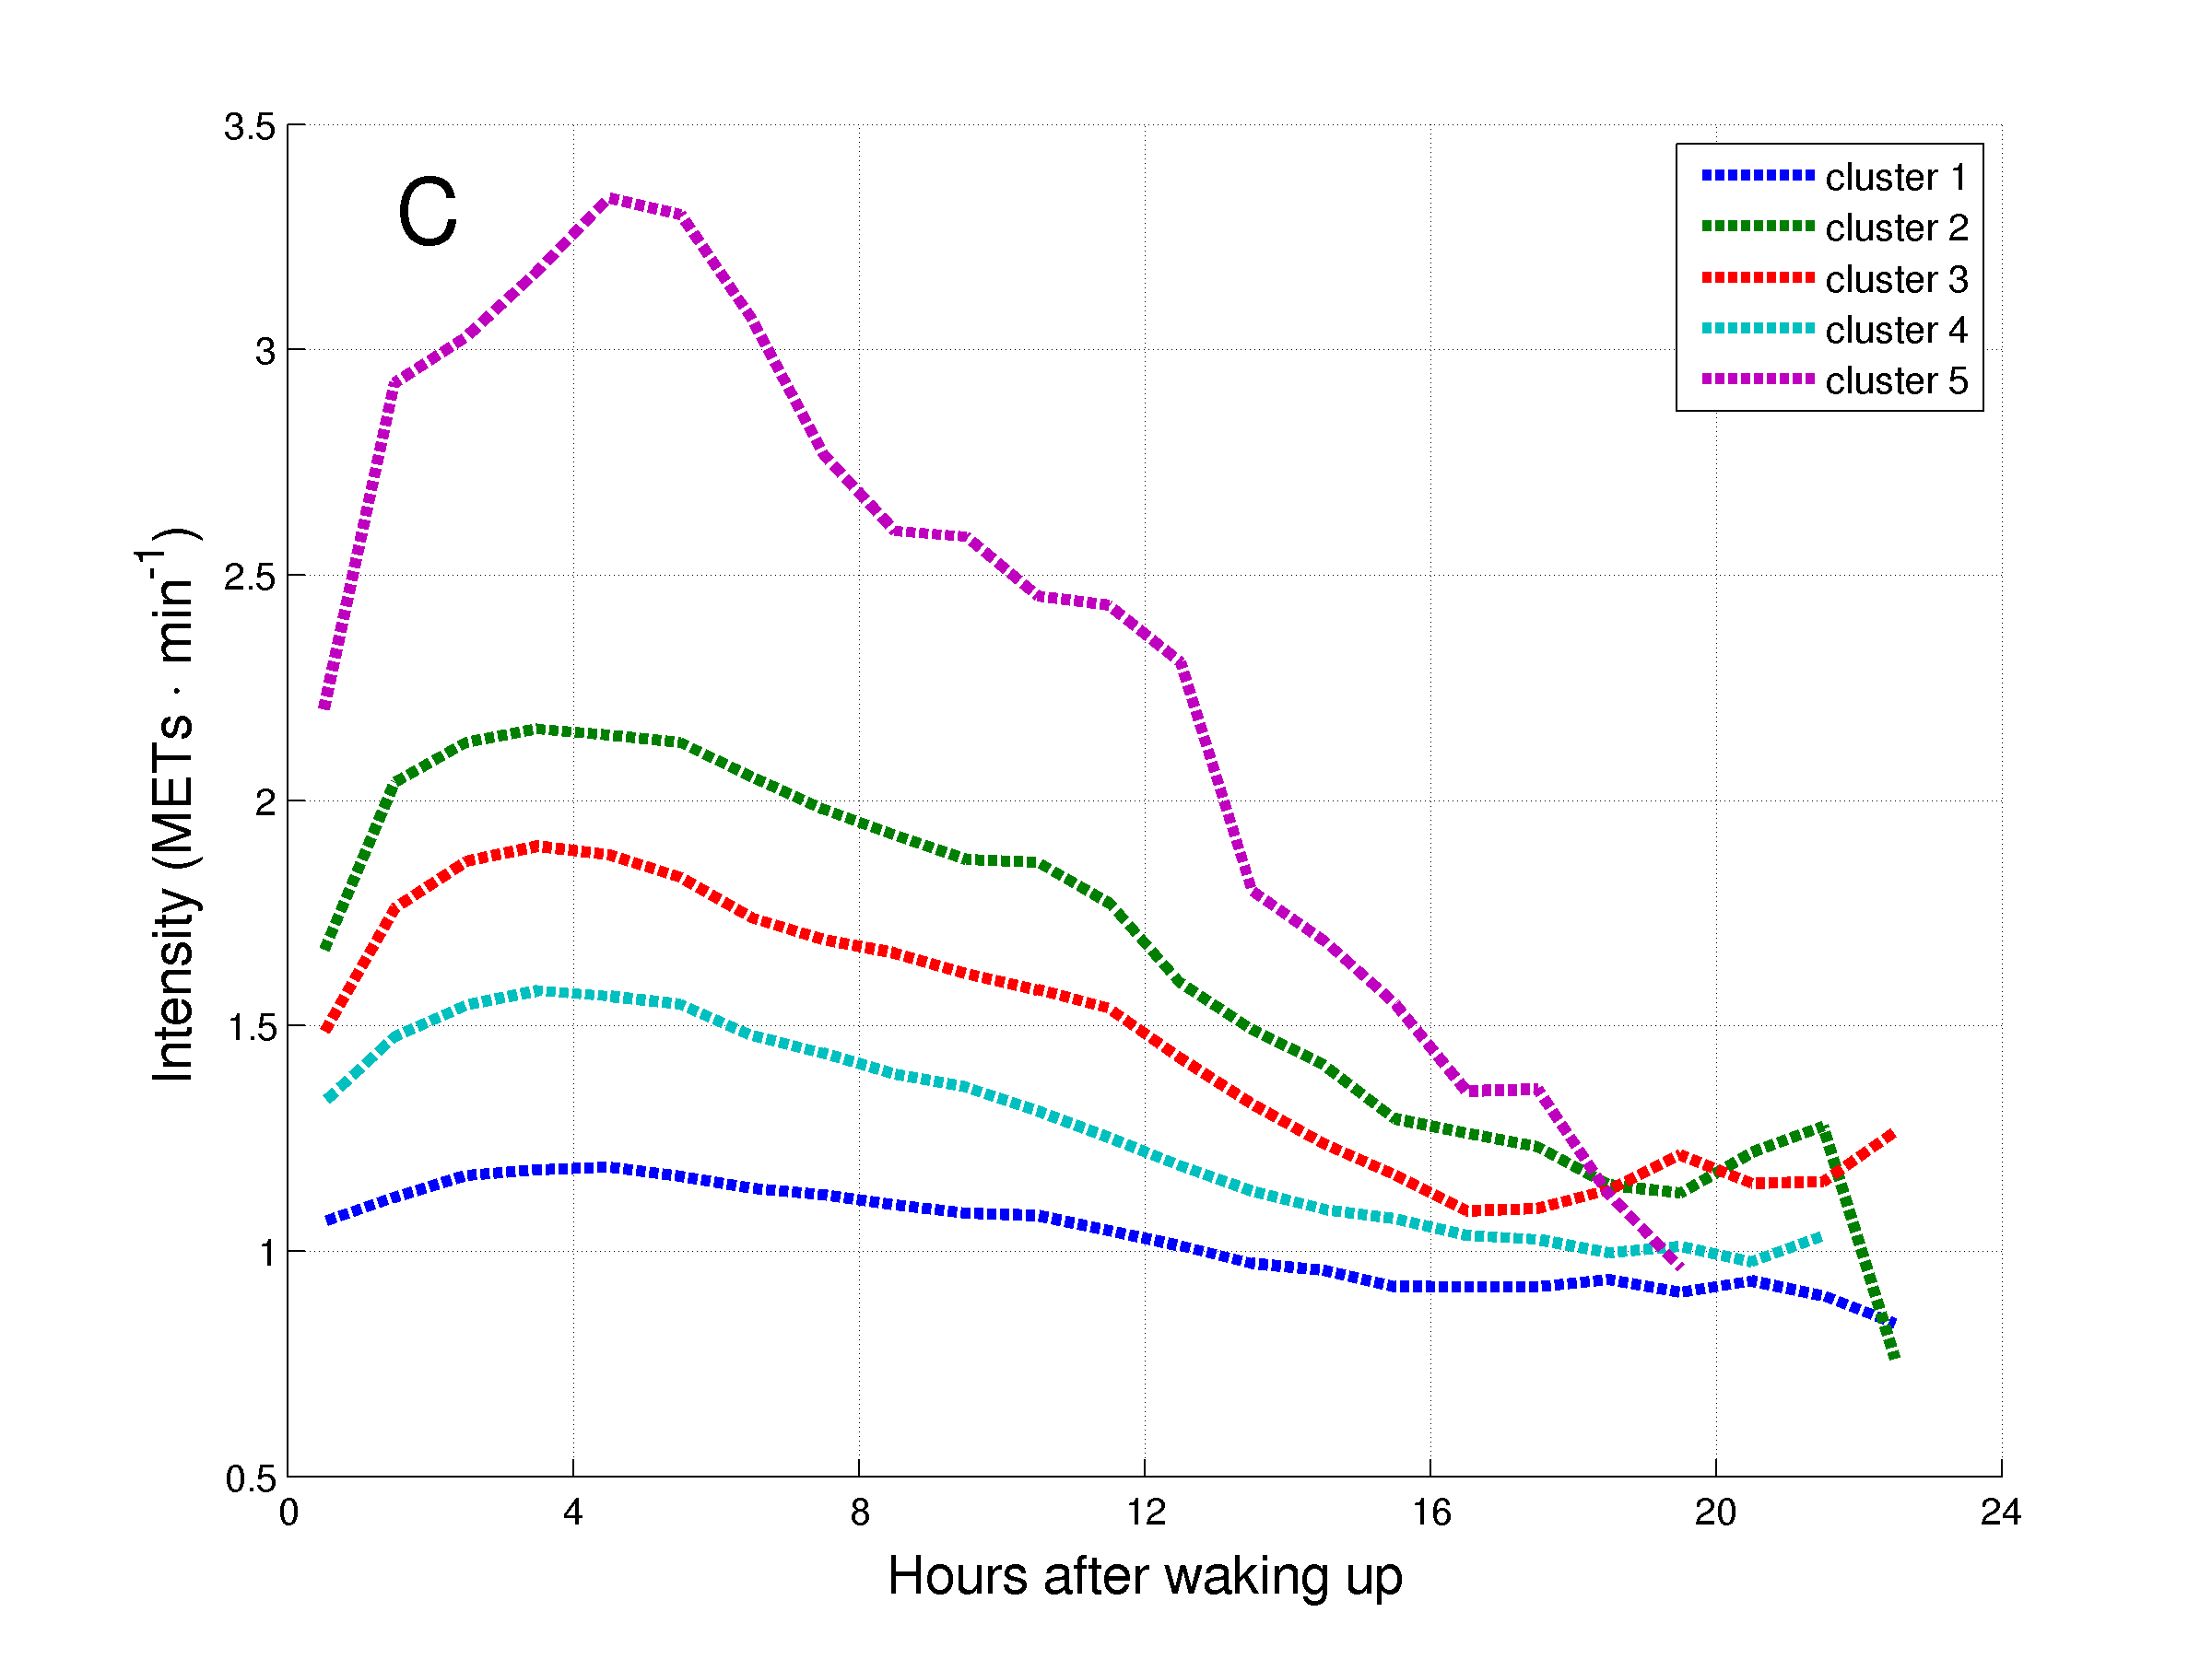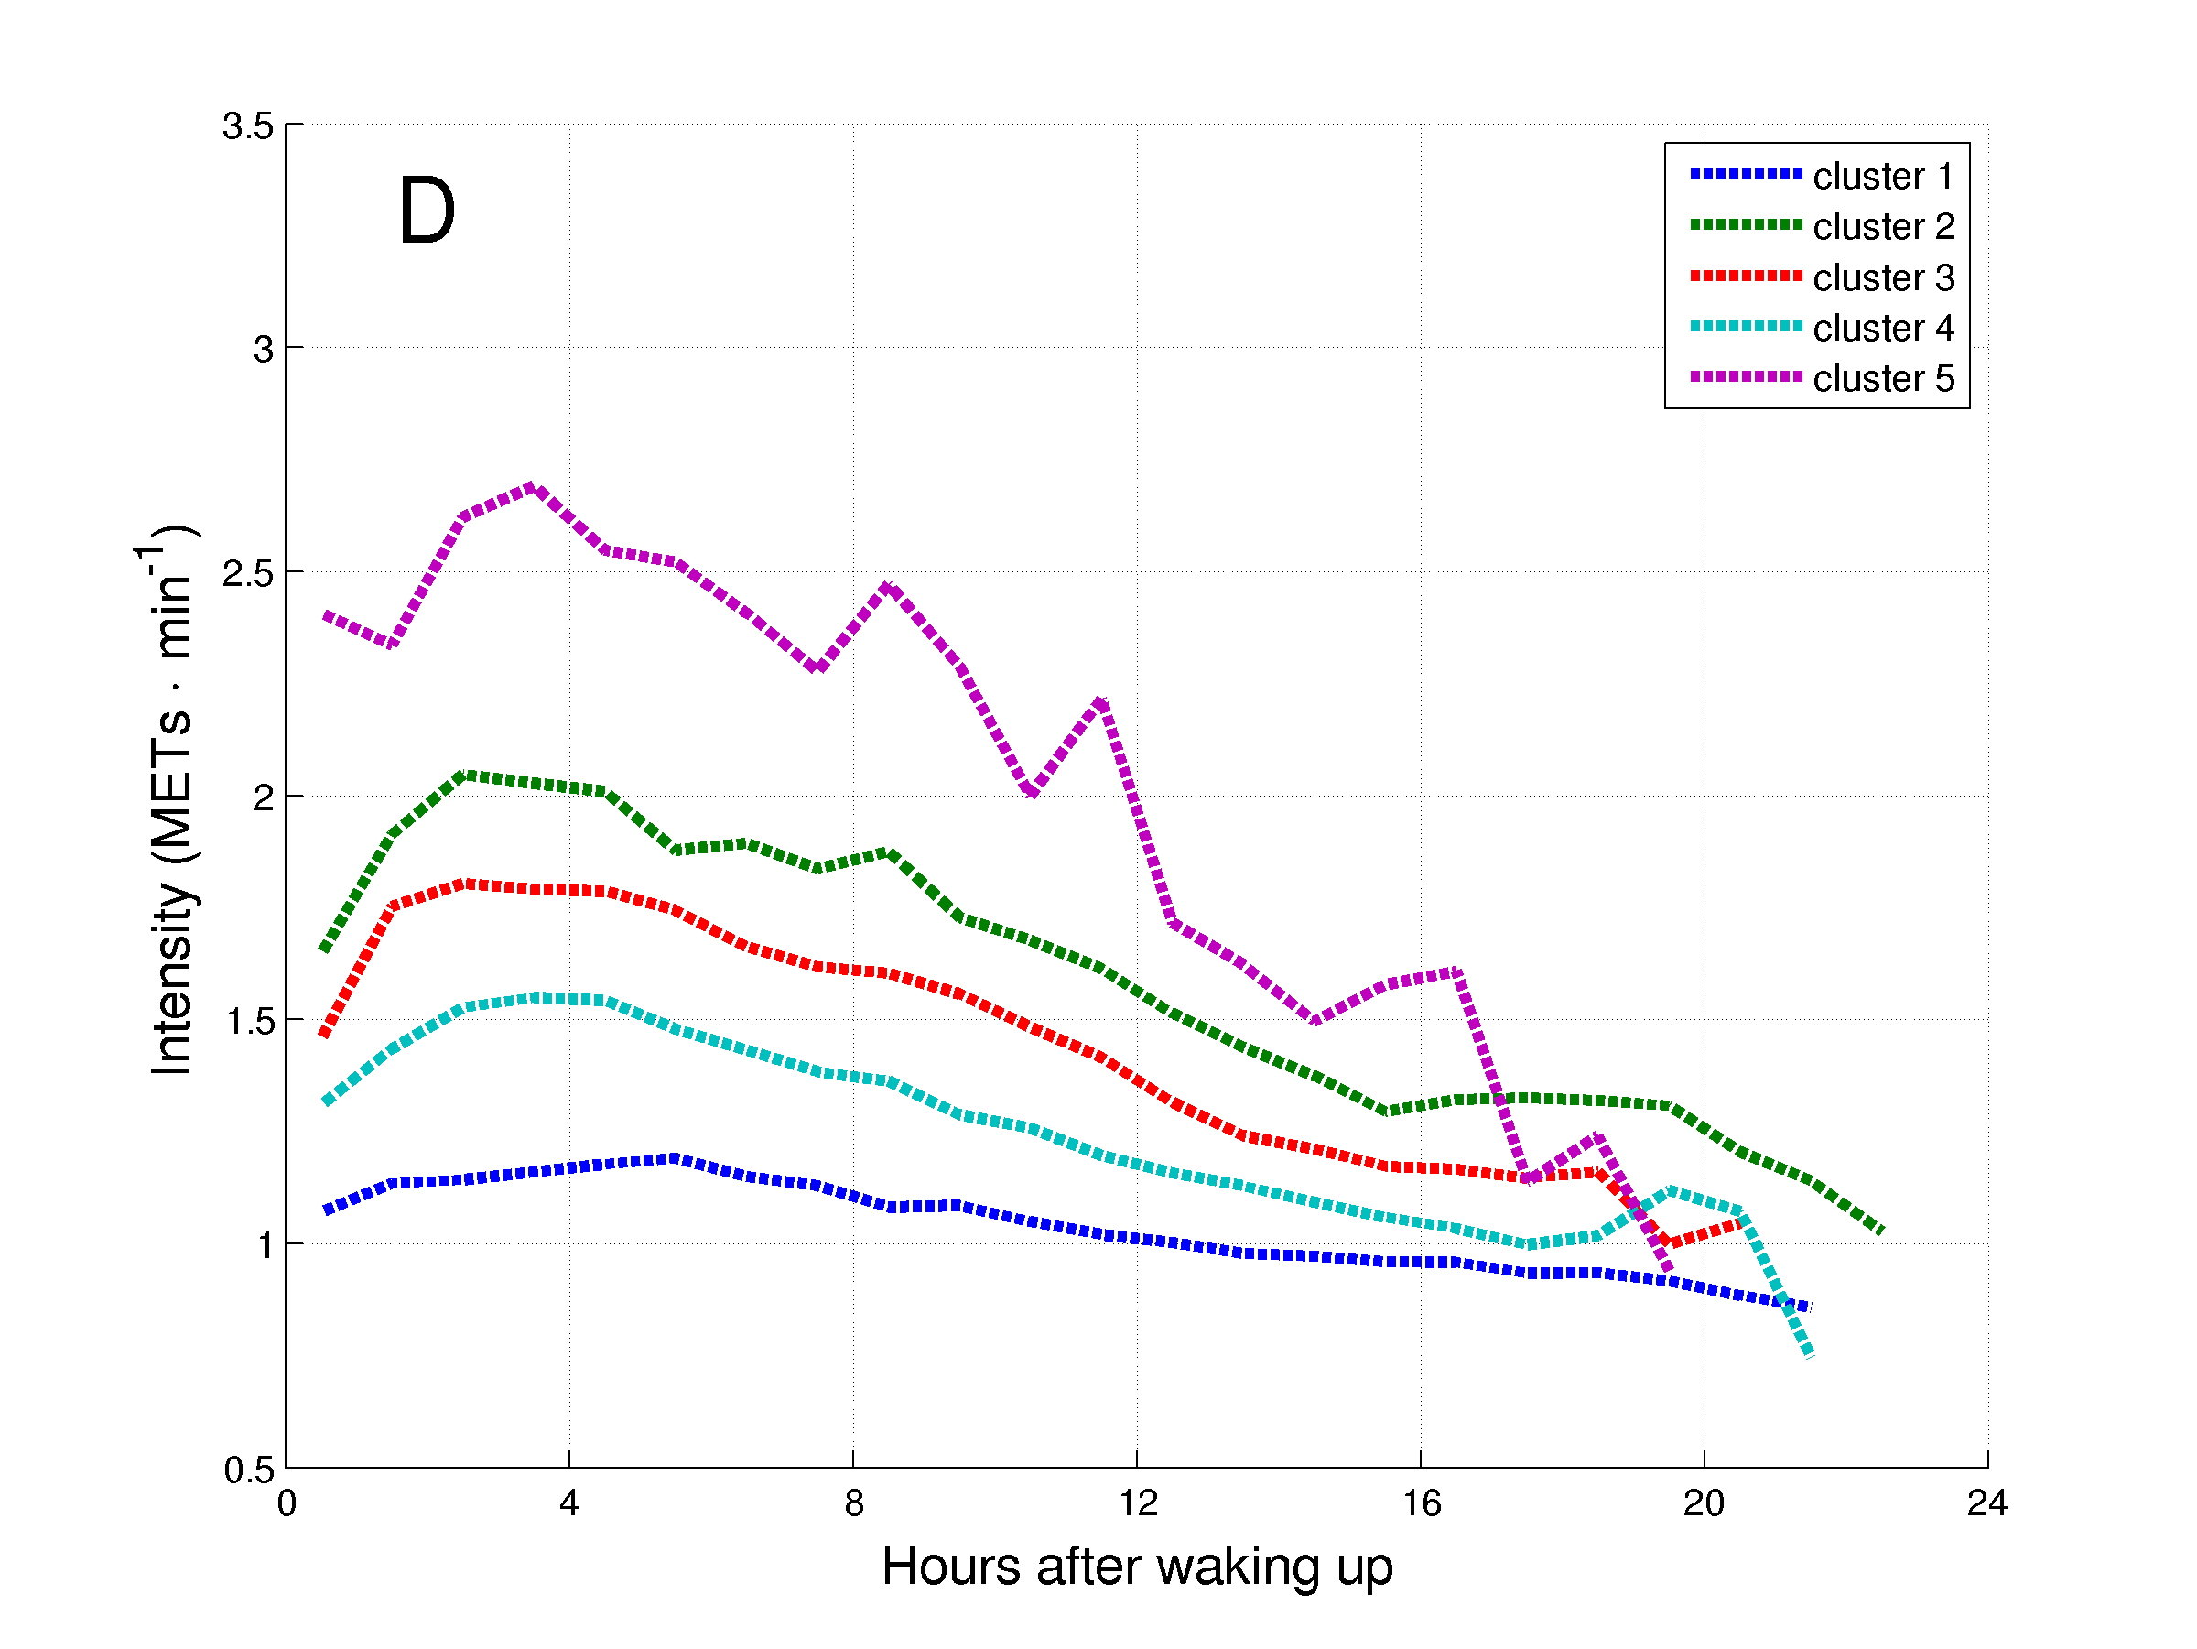
Figure 4. Daily hourly pattern of the clusters of patients with COPD during week (A and C) and weekend (B and D) days, and before (A and B) and after (C and D) synchronization of the waking up moment.

DISCUSSION (suggestion: no more than 5 pages)

This is the first study to demonstrate differences in physical activity pattern between patients with COPD and healthy control subjects. Moreover, clusters of physical activity were assessed in a broad, multi-center sample of patients with COPD. Clusters were identified based X, Y, and Z. Patients in the lowest activity cluster, had a higher proportion of women, and generally a higher degree of airflow limitation, and a higher BMI. Physical activity was higher in the morning compared to afternoon; and higher in the week days compared to the weekend days. This was true for all three physical activity clusters.

The heterogeneity of physical activity in COPD – plots with all raw data points?

The current study is the first to match patients with COPD to healthy subjects with similar age, BMI and gender, three known confounding factors of physical activity. – you should state in the methods how matching was done!

Clusters of physical activity
Clinical and research implications

General discussion (to be written).

To mention that is necessary that future studies also try to identify clusters, to check if similar clusters are identified, and to longitudinally validate the clusters identified. Also, to mention that is necessary that future studies check the impact of different ways of organizing the time in MVI on important health outcomes, such as survival.

To mention as a limitation: higher proportion of male subjects.

Strengths of the findings
The current sample of patients with COPD is by far the largest sample ever studied. This allowed us to study in depth physical activity clusters and patterns in patients with COPD, a true novelty within the COPD literature. This was only possible due to use of objectified physical activity.
Big sample, objective assessment of PA, novel analyses (bouts, sedentary time, cluster, and hourly pattern).

Limitations
How many patients came from different care settings??? For example, Leicetser were primary care…! Germany were mostly secondary care…! Etc!

In most centres, the sample was drawn from studies of pulmonary rehabilitation, what can compromise the external validity of the results. Samples from some centres were too small. Absence of other possible determinants of physical activity or variables which could discriminate the clusters, such as income and educational background. No validation in a longitudinal study.

The present study shows again that patients with COPD are physically less active compared to healthy subjects. Moreover, patients with COPD have a different physical activity pattern compared to controls. has advanced in the understanding of physical activity levels in patients with COPD by showing that ??? These findings have important clinical implications. (Suggest implications). Future studies should focus on the longitudinal validation of the clusters identified.
ACKNOWLEDGEMENTS

The authors would like to gratefully acknowledge all the subjects not included as co-authors in this study but that somehow helped with data collection in each centre. Add other acknowledgements.
REFERENCES

1 Pitta F, Troosters T, Spruit MA, et al. Characteristics of physical activities in daily life in chronic obstructive pulmonary disease. Am J Respir Crit Care Med 2005; 171:972-977
2 Sandland CJ, Singh SJ, Curcio A, et al. A profile of daily activity in chronic obstructive pulmonary disease. J Cardiopulm Rehabil 2005; 25:181-183
3 Walker PP, Burnett A, Flavahan PW, et al. Lower limb activity and its determinants in COPD. Thorax 2008; 63:683-689
4 Garcia-Aymerich J, Lange P, Benet M, et al. Regular physical activity reduces hospital admission and mortality in chronic obstructive pulmonary disease: a population based cohort study. Thorax 2006; 61:772-778
5 Waschki B, Kirsten A, Holz O, et al. Physical activity is the strongest predictor of all-cause mortality in patients with COPD: a prospective cohort study. Chest 2011; 140:331-342
6 Bossenbroek L, de Greef MH, Wempe JB, et al. Daily physical activity in patients with chronic obstructive pulmonary disease: a systematic review. COPD 2011; 8:306-319
7 Pitta F, Troosters T, Probst VS, et al. Quantifying physical activity in daily life with questionnaires and motion sensors in COPD. Eur Respir J 2006; 27:1040-1055
8 van Poppel MN, Chinapaw MJ, Mokkink LB, et al. Physical activity questionnaires for adults: a systematic review of measurement properties. Sports Med 2010; 40:565-600
9 Watz H, Waschki B, Meyer T, et al. Physical activity in patients with COPD. Eur Respir J 2009; 33:262-272
10 Pitta F, Takaki MY, Oliveira NH, et al. Relationship between pulmonary function and physical activity in daily life in patients with COPD. Respir Med 2008; 102:1203-1207
11 Hill K, Dolmage TE, Woon L, et al. Defining the relationship between average daily energy expenditure and field-based walking tests and aerobic reserve in COPD. Chest 2012; 141:406-412
12 Depew ZS, Karpman C, Novotny PJ, et al. Correlations between gait speed, 6-minute walk distance, physical activity, and self-efficacy in patients with severe chronic lung disease. Respir Care 2013; 58:2113-2119
13 Donaire-Gonzalez D, Gimeno-Santos E, Balcells E, et al. Physical activity in COPD patients: patterns and bouts. Eur Respir J 2013; 42:993-1002
14 Lee PH, Yu YY, McDowell I, et al. A cluster analysis of patterns of objectively measured physical activity in Hong Kong. Public Health Nutr 2013; 16:1436-1444
15 Trilk JL, Pate RR, Pfeiffer KA, et al. A cluster analysis of physical activity and sedentary behavior patterns in middle school girls. J Adolesc Health 2012; 51:292-298
16 Gubbels JS, Kremers SP, Stafleu A, et al. Clustering of energy balance-related behaviors in 5-year-old children: lifestyle patterns and their longitudinal association with weight status development in early childhood. Int J Behav Nutr Phys Act 2012; 9:77
17 Bussmann JB, van den Berg-Emons RJ. To total amount of activity..... and beyond: perspectives on measuring physical behavior. Front Psychol 2013; 4:463
18 Wardlaw AJ, Silverman M, Siva R, et al. Multi-dimensional phenotyping: towards a new taxonomy for airway disease. Clin Exp Allergy 2005; 35:1254-1262
19 Cindy Ng LW, Mackney J, Jenkins S, et al. Does exercise training change physical activity in people with COPD? A systematic review and meta-analysis. Chron Respir Dis 2012; 9:17-26
20 Steele BG, Belza B, Cain KC, et al. A randomized clinical trial of an activity and exercise adherence intervention in chronic pulmonary disease. Arch Phys Med Rehabil 2008; 89:404-412
21 Vestbo J, Hurd SS, Agusti AG, et al. Global strategy for the diagnosis, management, and prevention of chronic obstructive pulmonary disease: GOLD executive summary. Am J Respir Crit Care Med 2013; 187:347-365
22 Keys A, Fidanza F, Karvonen MJ, et al. Indices of relative weight and obesity. J Chronic Dis 1972; 25:329-343
23 Bestall JC, Paul EA, Garrod R, et al. Usefulness of the Medical Research Council (MRC) dyspnoea scale as a measure of disability in patients with chronic obstructive pulmonary disease. Thorax 1999; 54:581-586
24 Spruit MA, Singh SJ, Garvey C, et al. An official american thoracic society/european respiratory society statement: key concepts and advances in pulmonary rehabilitation. Am J Respir Crit Care Med 2013; 188:e13-64
25 Colbert LH, Matthews CE, Havighurst TC, et al. Comparative validity of physical activity measures in older adults. Med Sci Sports Exerc 2011; 43:867-876
26 Mackey DC, Manini TM, Schoeller DA, et al. Validation of an armband to measure daily energy expenditure in older adults. J Gerontol A Biol Sci Med Sci 2011; 66:1108-1113
27 Furlanetto KC, Bisca GW, Oldemberg N, et al. Step counting and energy expenditure estimation in patients with chronic obstructive pulmonary disease and healthy elderly: accuracy of 2 motion sensors. Arch Phys Med Rehabil 2010; 91:261-267
28 Hill K, Dolmage TE, Woon L, et al. Measurement properties of the SenseWear armband in adults with chronic obstructive pulmonary disease. Thorax 2010; 65:486-491
29 Cavalheri V, Donaria L, Ferreira T, et al. Energy expenditure during daily activities as measured by two motion sensors in patients with COPD. Respir Med 2011; 105:922-929
30 Garber CE, Blissmer B, Deschenes MR, et al. American College of Sports Medicine position stand. Quantity and quality of exercise for developing and maintaining cardiorespiratory, musculoskeletal, and neuromotor fitness in apparently healthy adults: guidance for prescribing exercise. Med Sci Sports Exerc 2011; 43:1334-1359
31 Waschki B, Spruit MA, Watz H, et al. Physical activity monitoring in COPD: compliance and associations with clinical characteristics in a multicenter study. Respir Med 2012; 106:522-530

FIGURE LEGENDS

FOOTNOTES

TABLES

FIGURES

